TraceMetrix
Software User Manual

Table of contents
1. TraceMetrix Overview 1
2. Initialization Operation 2
2.1. Login 2
2.2. Register 2
3. Home 3
4. Raw data management 3
5. Project 5
5.1 Project list 5
5.2. Create New Project 5
5.3. Edit project 6
6. Analysis 6
7. Preprocessing 6
7.1. Quantitative analysis 8
7.2. Annotation(Qualitative analysis) 10
8. Data cleaning 12
8.1. Background Removal 15
8.2. Missing Value Processing 18
8.3. Normalization 21
8.4. Filtered by RSD 23
8.5. Data Integration 25
8.6. Outlier Removal 26
9. Statistical analysis 27
9.1. Univate Analysis 28
9.2. Multivariate Analysis 32
10. Function analysis 36
10.1. Correlation Analysis 37
10.2. Linear regression 39
10.3. Logistic regression 40
10.4. Survival Analysis 42
10.5. Enrichment Analysis 45
11. One click analysis 50
12. My Analysis 52
13. Data lineage 53
13.1. Process traceability 53
13.2. File traceability 53
13.3. Software traceability 53
14. Help 54

TraceMetrix Overview
This metabolomics data analysis platform includes three modules: quantitative and qualitative analysis of raw mass spectrometry data, data cleaning, and statistical analysis (the specific flow chart is shown below).
Quantitative and qualitative analysis include: quantitative analysis of non-target data (converting raw mass spectrometry data into analyzable two-dimensional matrices), supporting 6 formats of mass spectrometry file data input and providing 6 instrument-specific parameter selections; qualitative analysis of non-target data (metabolite annotation), supporting primary (6 databases) and secondary annotations (4 databases) of metabolites.
Data cleaning includes: background noise removal (including two methods: using blank samples or gradient dilution samples); missing value processing (deleting features with missing value ratios exceeding a certain threshold); missing value filling (methods include: random forest, mean, median, minimum value, half of the minimum value, and 0); data normalization (methods include: QC-based support vector regression, median value, and total area normalization); feature filtering based on QC RSD; batch data integration; outlier identification and deletion.
Statistical analysis included: univariate statistics (including two-sample test and multi-sample test); multivariate statistics (including PCA, PLS-DA, OPLS-DA); metabolite enrichment analysis; correlation analysis (including Pearson, Spearman, Kendall); linear regression (including simple linear regression and multivariate linear regression); Logistic regression (including binary logistic regression, unordered multi-classification logistic regression, ordered multi-classification logistic regression); survival analysis (including Kaplan-Meier method and COX proportional hazard regression).
In addition, the platform has a project management function, providing users with data management and analysis results management. The analysis results can be browsed and interacted online; the analysis results of each analysis step can be downloaded online.

Initialization Operation

Login
Visit the TraceMetrix Platform homepage and click the "Login" button in the upper right corner (Figure 2.1-①), jump to the login interface of the NODE database to log in, and fill in the correct user name (Username) and password (Password) on the "NODE" login interface to log in.
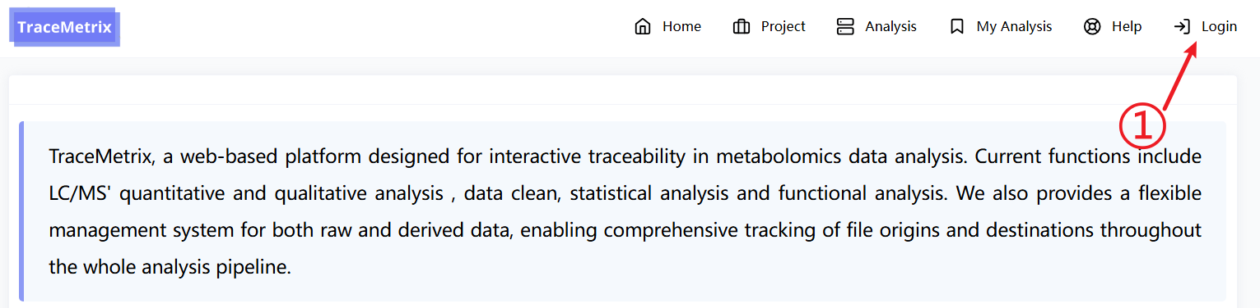
Figure 2.1 TraceMetrix home page
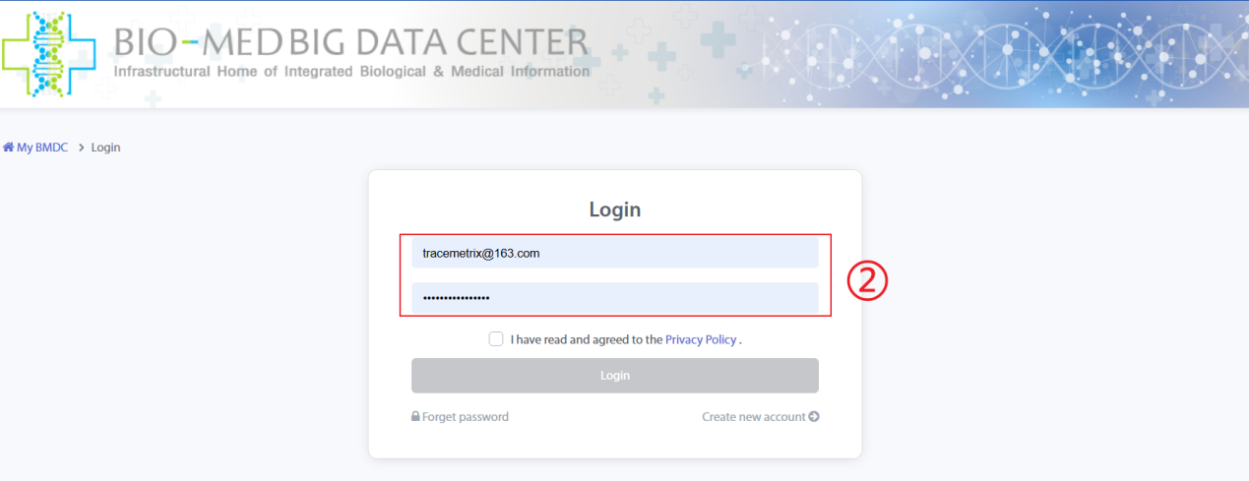
Figure 2.2 User login page

Register
If the user is visiting for the first time, they need to register an account. Click "Create new account" to register a new user and fill in the corresponding information as required. After the registration is completed and passed the review, you can log in normally
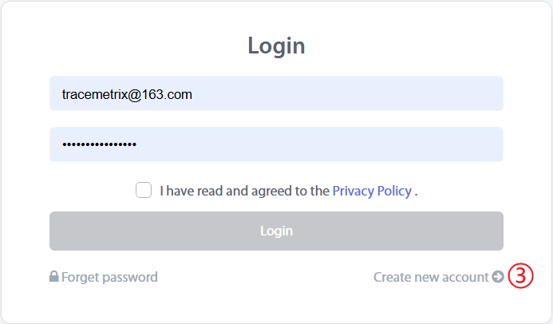
Figure 2.3 User registration

Home
The home page introduces the TraceMetrix platform and the modules and analysis processes of the analysis functions:
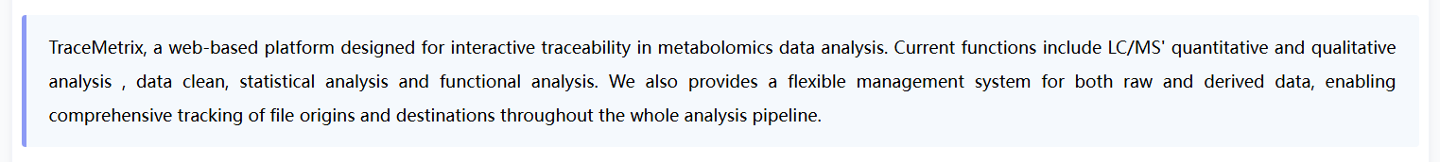

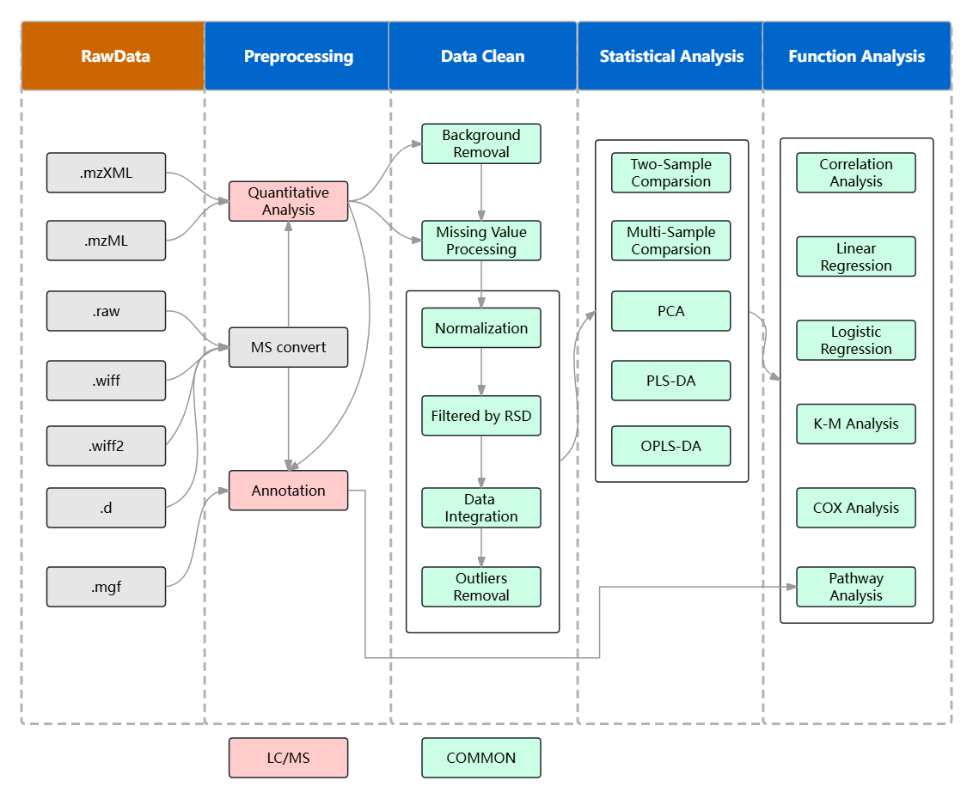
Figure 3.1 Home

Raw data management
The personal center module is mainly provided for users to manage personal data, including some information of File Manager.
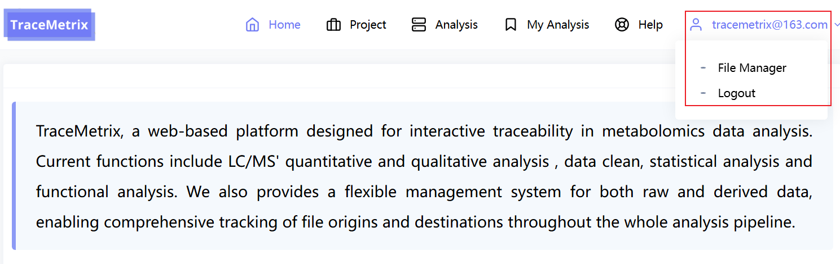
Figure 4.1 My Information Interface
When the user enters the "File Manager" page, the user manages the raw mass spectrometry data on this page. The user needs to transfer the raw data to TraceMetrix via FTP. Commonly used FTP tools include FileZilla, XFTP, etc. After the user opens the FTP tool, the user needs to first enter the host (sftp://fms.biosino.org) and port (44400), and then enter the user's account and password in TraceMetrix, so that the raw mass spectrometry data can be uploaded at high speed.

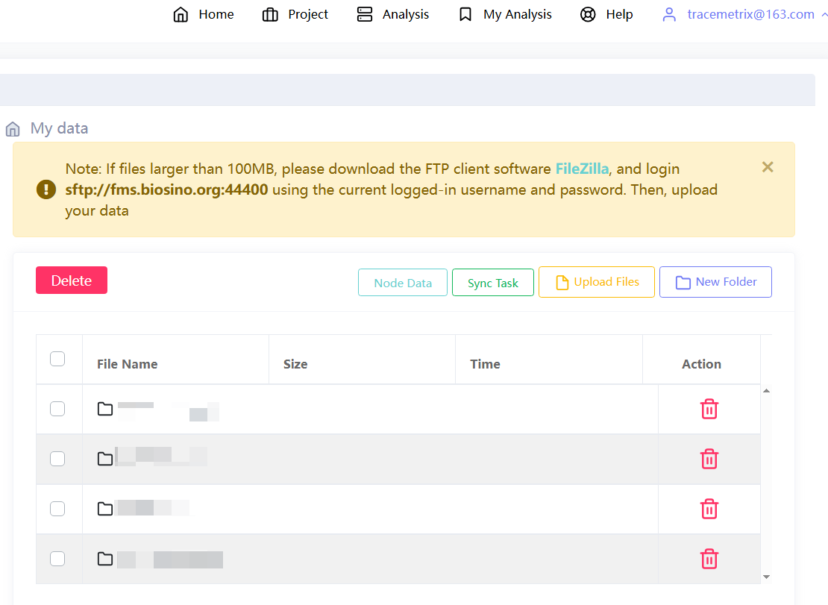
Figure 4.2 Raw data management interface
Notice: When users upload raw data, it is recommended to create a project for the raw data of each project. If there are two different example modes, Positive and Negative, it is recommended to upload them in separate folders! In addition, we recommend uploading the original mzML format as mass spectrometry data

Project

5.1 Project list
Metabolic Analysis Platform Click "project" to enter the project list. Display all the projects established by the logged-in user and provide search (⑧）、New（①),edit(②), delete Project (②) and project notes (⑦) and other functions.
Each project includes experimental data, analysis modules (④) and the number of tasks to which the analysis module belongs (⑤). Click⑤Each task number in can directly jump to the detailed result page of the corresponding module.
Click⑥You can jump to different modules for corresponding analysis: from left to right, they are Preprocess, jump to the preprocessing page; click Data cleaning to jump to the data cleaning page; click Statistic analysis to jump to the statistical analysis page; click Function analysis to jump to the functional analysis page; and click One-click analysis to jump to the one-click analysis page.
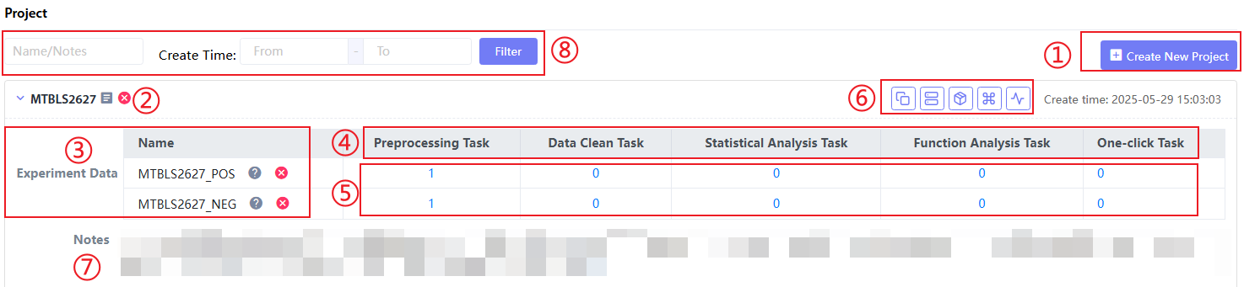
Figure 5.1 Project page

5.2. Create New Project
Click "Create New Project" on the Project page to enter the Add Project page to add a user project. Notes records project notes. Note that the 'Project name' should not exceed 10 words, should not be repeated with existing project names, and should preferably contain specific information for easy management and search.
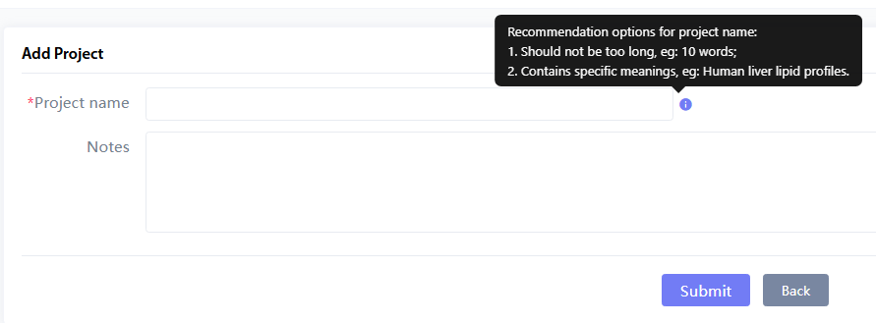
Figure 5.2 Create a new project

5.3. Edit project
Click "edit project" on the Project page (Figure 5.1:②), enter the edit Project page to edit and modify the basic information of the user project.
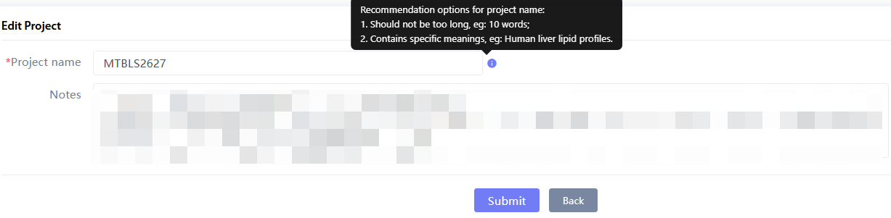
Figure 5.3 Edit project

Analysis
"Analysis" in the navigation bar is the entrance to the specific analysis function of the TraceMetrix analysis platform. Click "Analysis" to enter, which includes two parts: "One Click Analysis" and "Step by Step Analysis".
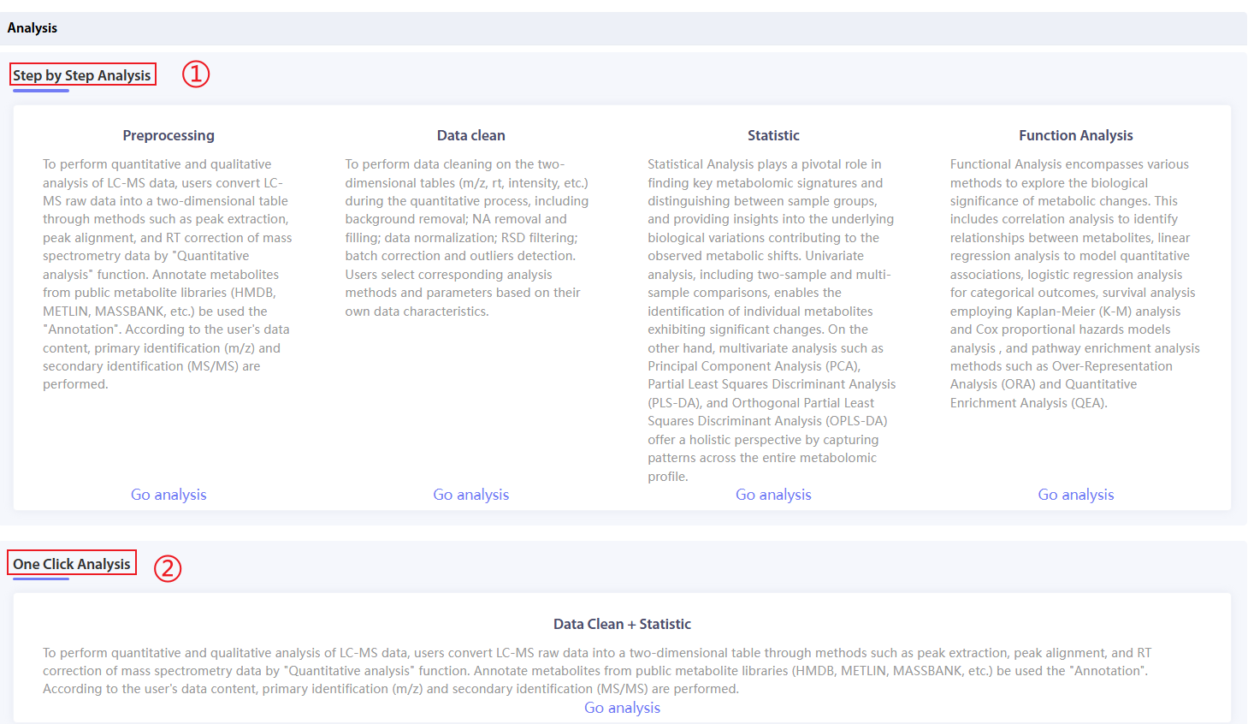
Figure 6.1 Analysis page
Figure 6.1①The representative is "Step by Step Analysis", which mainly includes the introduction of 19 analysis functions in the four analysis modules currently included in TraceMetrix. Click "Go analysis" of different analysis modules to enter different modules for analysis.
Figure 6.1①The representative function is "One Click Analysis", which currently integrates all data cleaning functions (6) and some statistical analysis functions, and is used to clean metabolic abundance matrix data with one click and quickly obtain differential metabolite characteristics.

Preprocessing
Click "Preprocessing" on the Analysis page to start the mass spectrometry data preprocessing phase. Click "choose" (①) After selecting a project, the quantitative and qualitative analysis functions in the project are displayed and search and new functions are provided. After selecting the project, click "upload" to select the original mass spectrometry experimental data to be analyzed (③); click④Click "Edit data" in the menu to view and edit the selected mass spectrometry data.④Click "View task" to display the task list for the data in this module.⑤Fill in the task name and task notes for this processing. Note that the task name cannot be repeated.
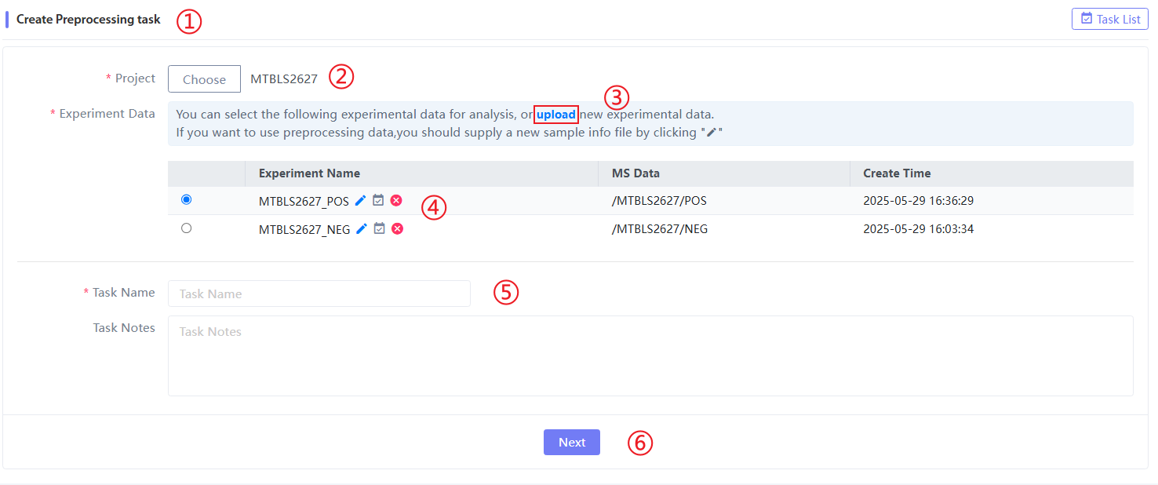
Figure 7.1 Preprocessing data selection page
Click on the③and④Enter the Add/Edit Experimental Data page (the page content is the same), fill in the experimental name (required) and experimental content, click 'Select' in "Ms Data" to upload mass spectrometry experimental data, and you can upload raw mass spectrometry data through FileZila. You can upload data through FileZila as required.
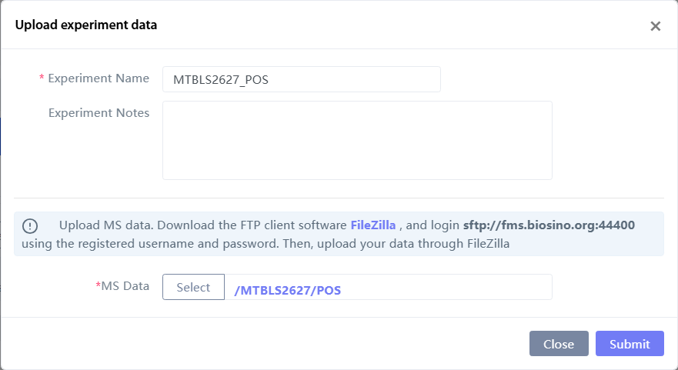
Figure 7.2 Upload new/edit experimental data

Quantitative analysis
After the experimental data is prepared, click next to enter the data preprocessing selection interface:
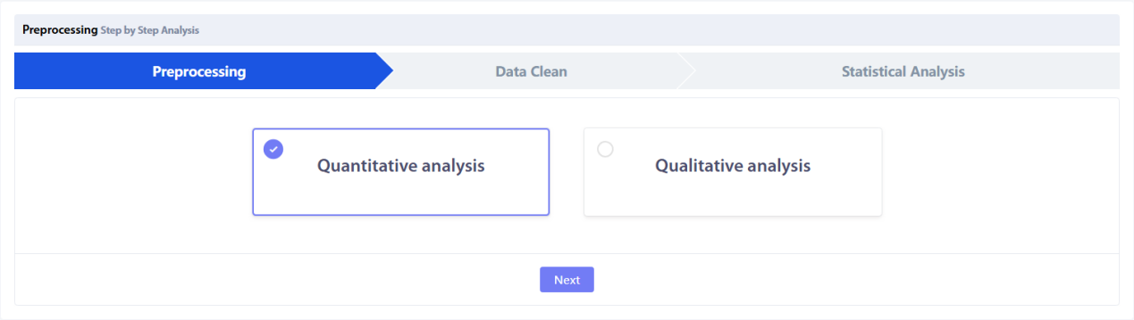
Figure 7.3 Preprocessing function selection page
After selecting "Quantitative analysis", the specific quantitative analysis parameter selection page is displayed:
- “Ms Data” is the selected raw mass spectrometry data to be analyzed;
- "Sample Info File" is the quantitative analysis sample information file, which must include the columns "file.names", "sample.name", and "classes" (only three columns);
- Select the data format parameters according to the experimental data format. Currently, 6 data formats are supported.Use the format "Open" (.mzXML, .mzML)and instrument offline formats "Vendor" (.wiff, .wiff2, .raw, .d);We recommend using the .mzML format for data preprocessing. It should be noted that if the data is converted to the .mzML format using a different mass spectrometer, it needs to be centroided before it can be imported into TraceMetrix..
- Select “positive” or “negative” according to the ion mode of the mass spectrometry data;
- For the selection of specific parameters for quantitative analysis, we exposed the parameters processed by the XCMS software package (R). Currently, 1 general parameter and 5 different instrument parameters are provided for selection. Users can also adjust the specific parameters by themselves.
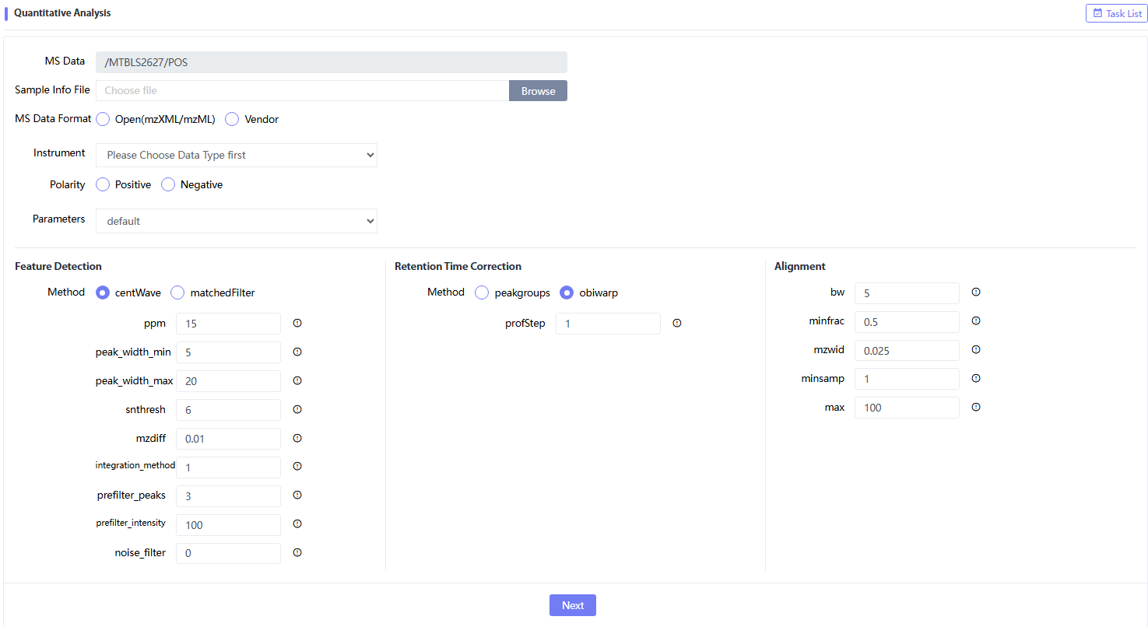
Figure 7.4 Quantitative analysis parameter selection page

After clicking "Next", you can enter the quantitative results page and wait for the results to be generated. The results are mainly composed of five parts:①and⑩For project information;⑧The status and quantity of analysis tasks for different modules under this project;③and⑨The task information of the experimental data, including existing tasks, new tasks and deleted tasks;②To select a specific task name and notes;④,⑤and⑦Indicates the specific task function analysis, including the selected parameters and the status of the specific analysis function analysis.⑥Representative quantitative analysis results

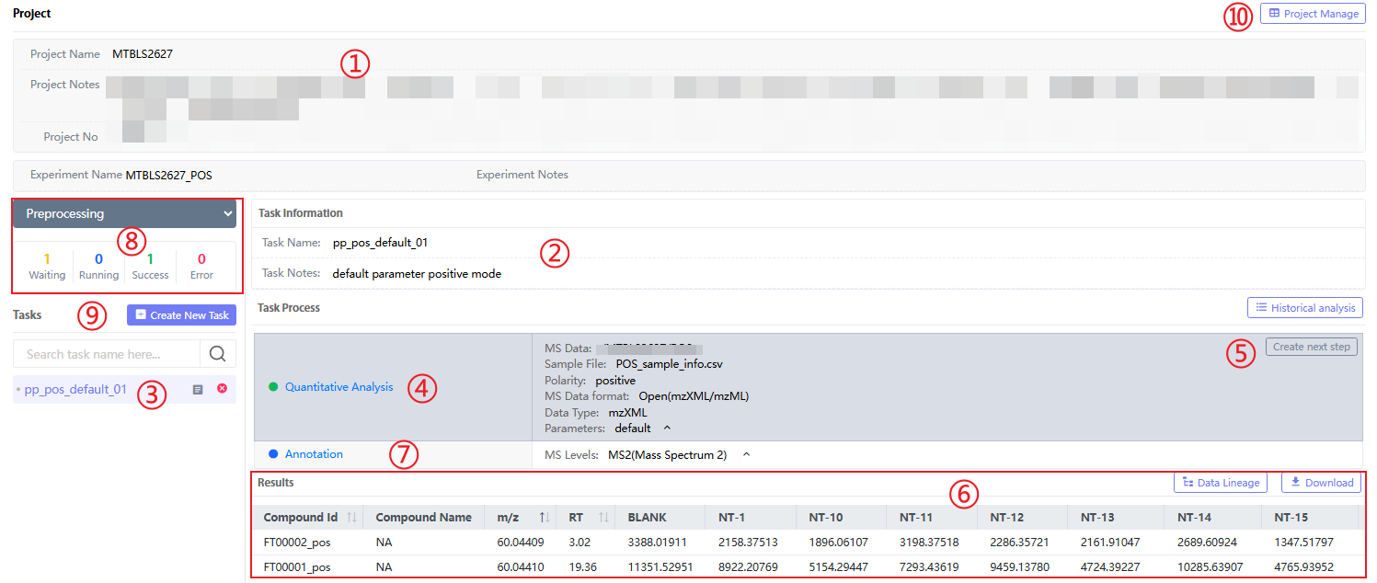
Figure 7.5 Preprocessing quantitative results page
In Figure 7.5⑥In the figure, there is an online table of quantitative results. The upper right corners represent the data traceability "Data Lineage" and the download "Download" button. Click "Download" to download the results of the quantitative analysis to your local computer. Click the "Data Lineage" button to display the data traceability of the analysis function in a pop-up window:
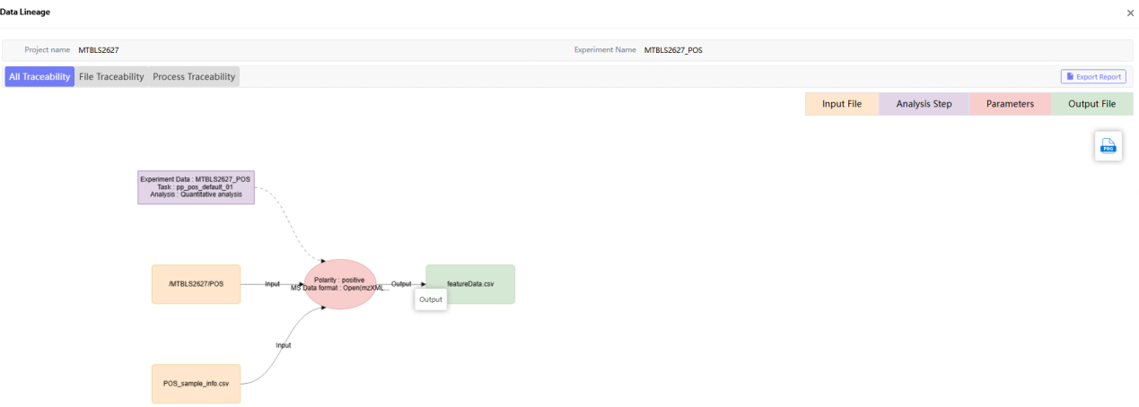
Figure 7.6 Preprocessing quantitative result traceability page
In addition, click "Historical analysis" in the upper right corner of the quantitative analysis result page to enter the historical analysis of the analysis. Click different buttons in "Action" to delete or re-analyze the step.
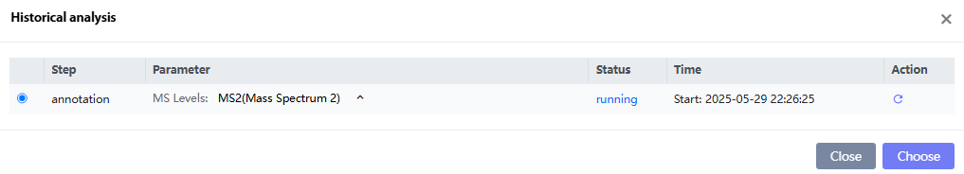
Figure 7.7 Preprocessing quantitative results historical analysis page

Annotation(Qualitative analysis)
When metabolite annotation analysis is required, place the mouse on the right side of the "Quantitative Analysis" line and click the suspended "Create next step" to perform annotation analysis. Metabolite primary annotation and metabolite secondary annotation are supported. Metabolite secondary annotation requires a secondary annotation file (if secondary information exists in the original file, it can be directly converted to the specified format). In addition, 5 primary metabolite libraries and 3 secondary metabolite library annotations are provided, and users can choose.
Parameter Description:
(1) "levels" refers to the level of annotation required (MS1 and MS2). Select the corresponding level according to the existing mass spectrometry data. "MS1 File" is a two-dimensional table containing RT (rention time) and m/z (mass/z ratio), which is generally derived from quantitative analysis.
(2) "MS2 File(s)" is to select files containing MS2 mass spectrum information. The input format is required to be mgf, which is generally converted directly from the original mass spectrum file;
(3) “MS1 Database” refers to the MS1 annotation database;
(4) “MS2 Database” refers to the MS2 annotation database;
(5) "Polarity" is the mass spectrometry data ion mode, select "positive" or "negative";
(6) “MS1 Match ppm” is the error between the ppm (parts per million, unit) of the metabolite and the ppm of the metabolic peak in the MS1 annotation, which is generally set between 10-30 ppm;
(7) “Candidata Num” is the number of annotated metabolite candidates, generally between 1 and 5;
(8) “Colum” is the chromatographic separation mode used in mass spectrometry experiments, which is divided into hydrophilic (hilic) and hydrophobic (rp).
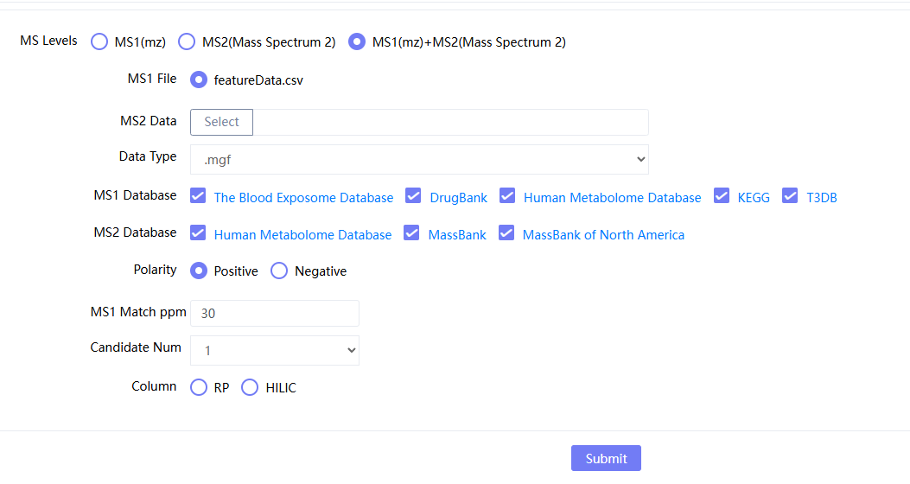
Figure 7.8 Preprocessing-Annotation parameter selection page

After selecting the parameters, click "Submit" to enter the result page. The XCMS and Annotation results under the same Task are on the same result page. Click "Annotation" to display the annotation results; click "Download" on the right side of the result to package and download the results. The results include a visual table and the "Name" column in the table. If there is a secondary map, click it to jump to view the secondary map comparison results.
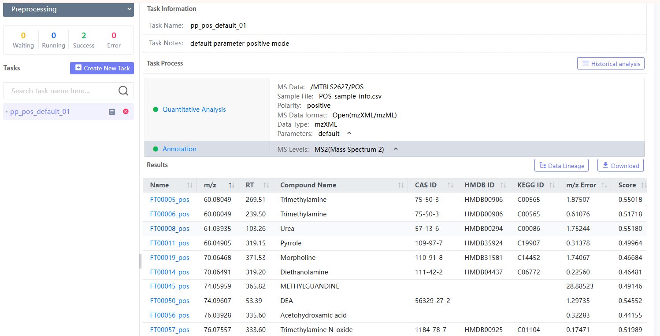

Figure 7.9 Preprocessing Annotation results
After clicking 'Data Lineage', the traceability results of the annotations can be generated:
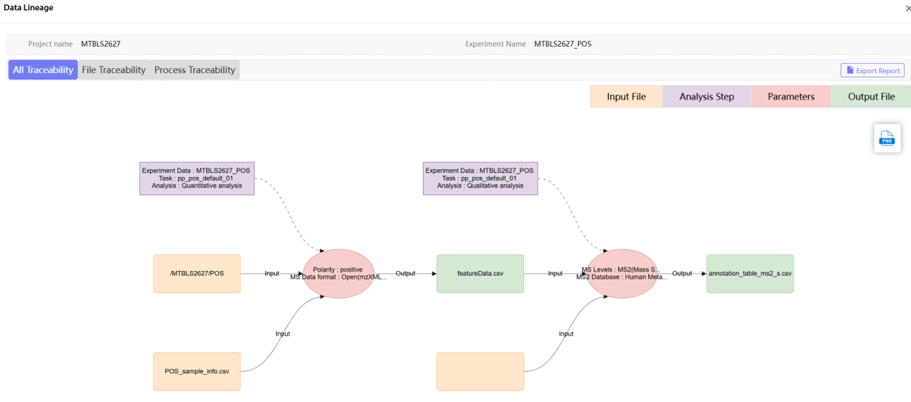
Figure 7.10 Pre-Process Annotation results

Data cleaning
Click "data cleaning" on the Analysis page to start the data cleaning module. Click "choose" (①)After selecting a project, the cleaning tasks in the project are displayed and search and add functions are provided; click "upload" (②) to upload the cleaned experimental data, click④In the "Edit data" in the browse and select the uploaded quantitative matrix data and sample information file; click "task list" (⑦) displays the task list.
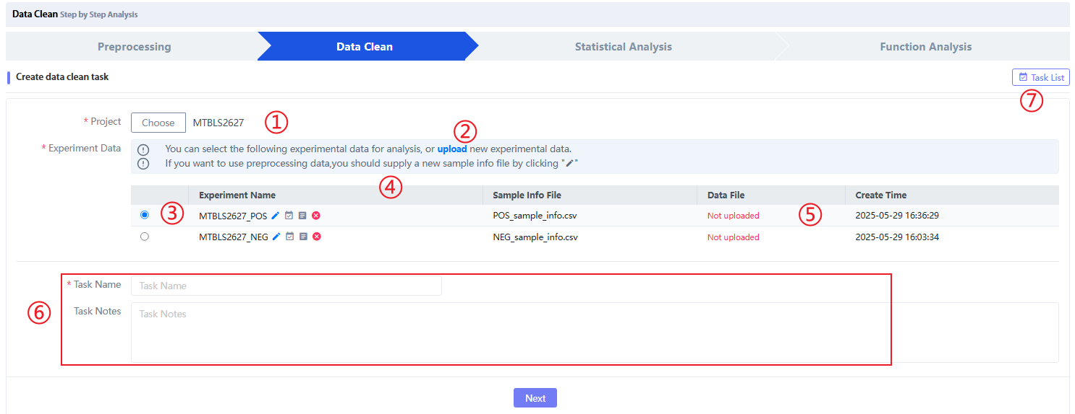
Figure 8.1 Data cleaning
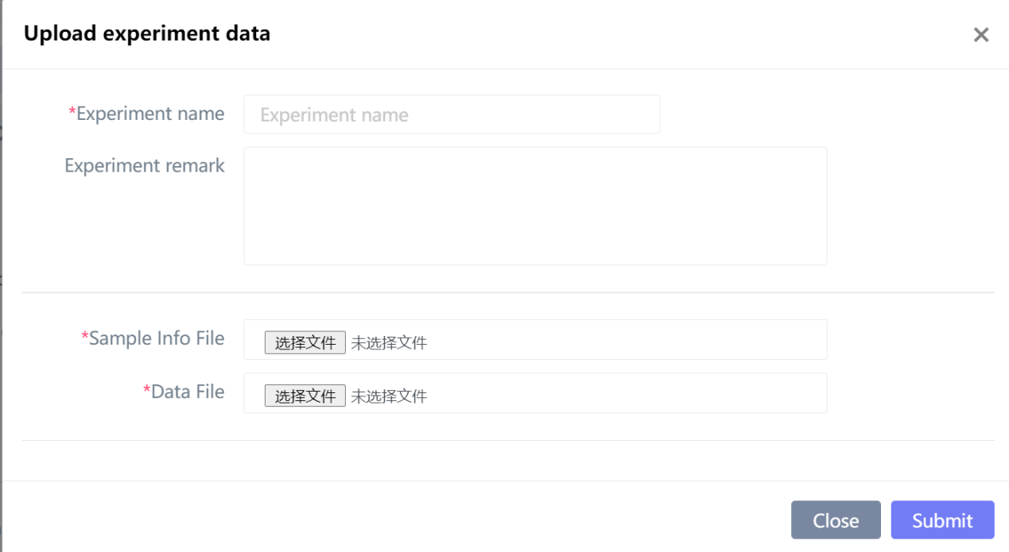
Figure 8.2 Data cleaning page uplod new project data
Click on the④Click “Edit data” to browse and select the uploaded quantitative matrix data and sample information file. Please note: 1) If you need to continue analyzing the quantitative analysis results under this experimental data, select②1) If you do not want to continue analyzing the quantitative results of the experimental data, select②Click “Upload” in the search box to re-upload the quantitative analysis data (usually metabolic abundance matrix) and sample information file.
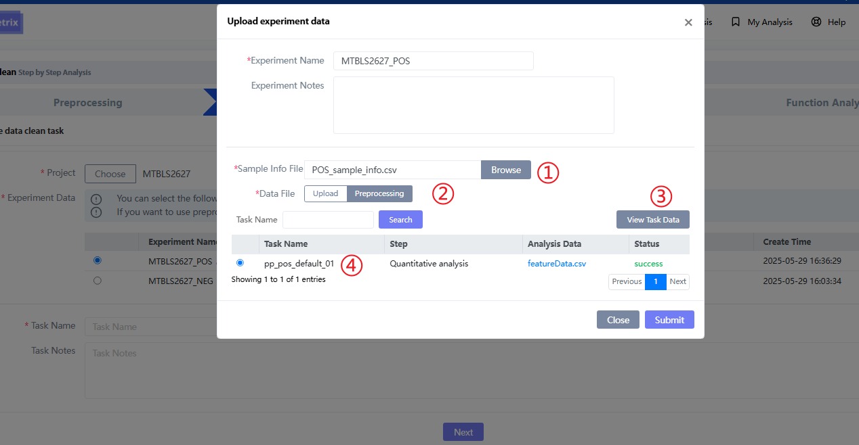
Figure 8.3 Data cleaning and editing data page
Click "Next" to enter the specific data cleaning function analysis page, which includes①For project information;②For sample information;③For all analysis functions in the data cleaning module;④For a specific analysis function, click the dot above to jump to the function to select parameters or view the analysis status;⑤To select the analysis function parameters, after selecting the parameters, click "Next" to enter the next analysis step.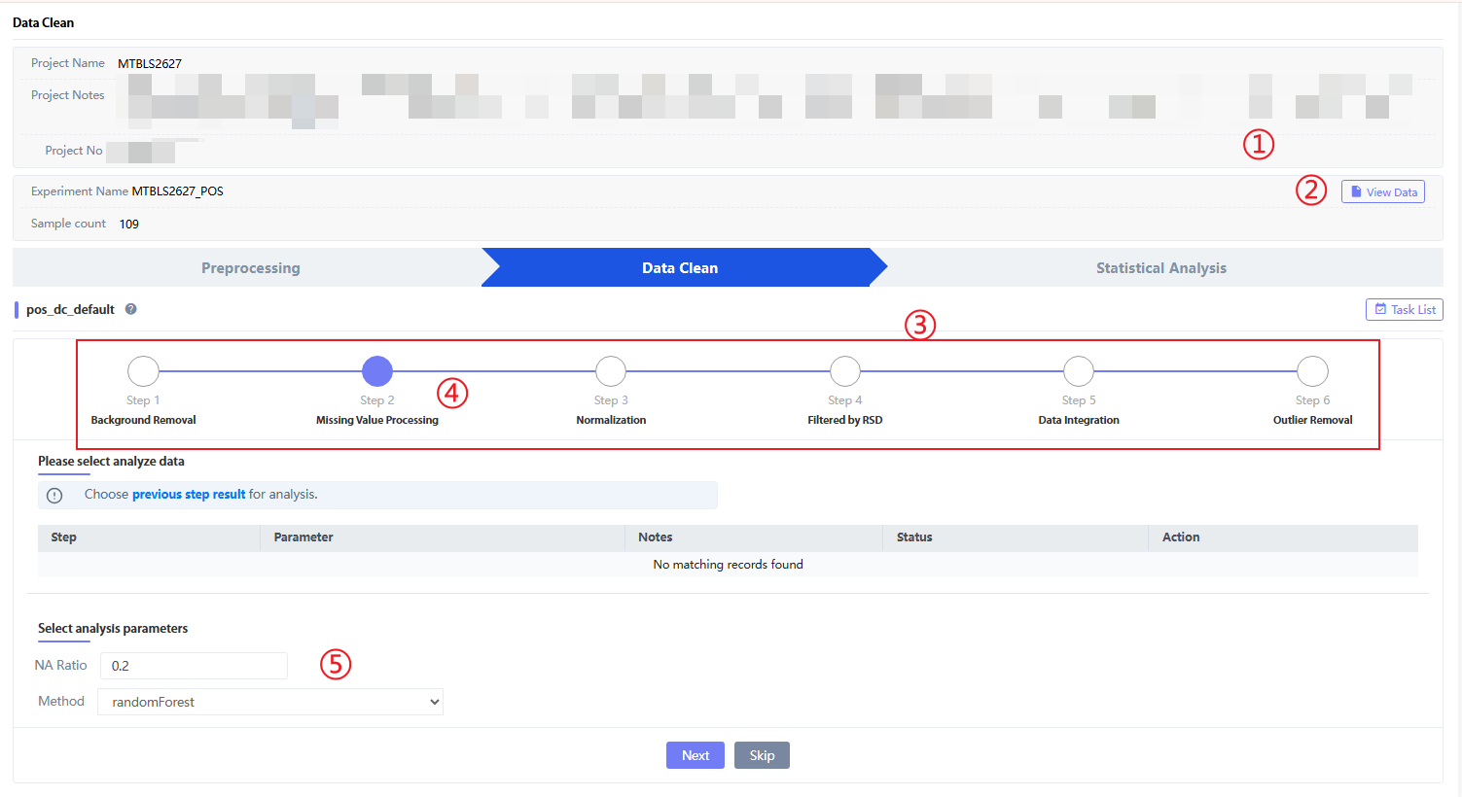
Figure 8.4 Data cleaning function and parameter selection page
Click on the②"View data" browses the uploaded sample information data, including sample name, injection order, and sample category information (usually Sample and QC, if there are blank samples or sparse samples, then Blank and Dilution).
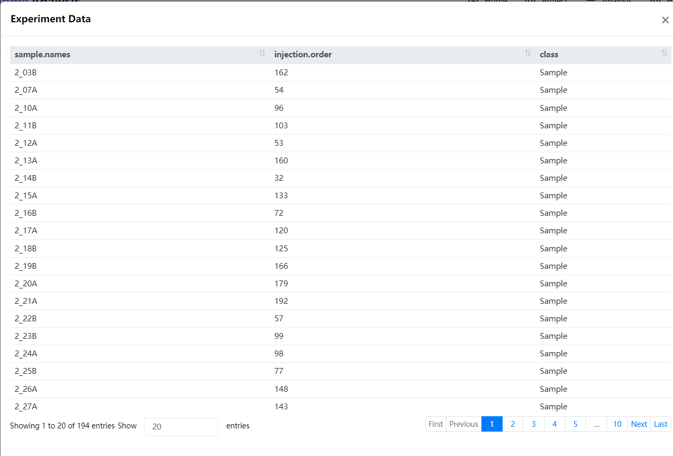
Figure 8.4 Online viewing of data cleaning sample information

Background Removal
After preparing the experimental data, click "next" to enter the first step of data cleaning: Background Removal, which is used to delete "error peaks" caused by system factors. Before doing this step, you need to determine whether there is a blank sample (Blank) or a dilution gradient sample (Dilution) in the sample. Otherwise, select "Next" to wait for the analysis results and proceed to the next step of data cleaning. Select the analysis parameters as follows:
Parameter Description:
- When method is selected as "balnk", the parameter fold is the multiple of the peak in the Blank sample and the peak in the experimental sample;
- When the method is selected as "dilution", the parameter fold is the multiple of the peak in the diluted sample and the peak in the experimental sample, and the parameter r2 is the gradient of the diluted sample.
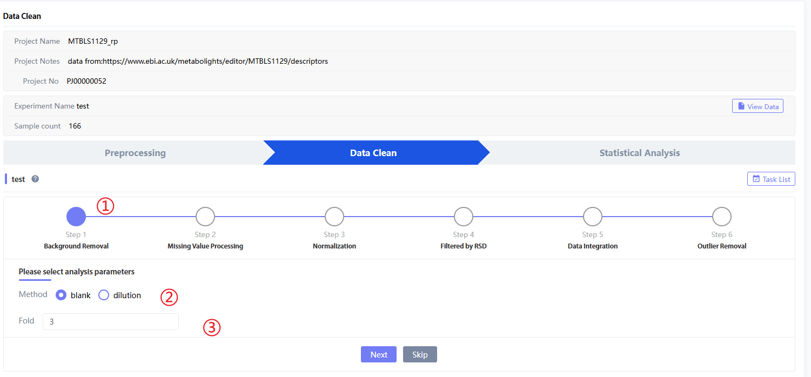
Figure 8.5 Background Removal analysis and parameter selection
After clicking "Next", jump to the next step.Missing Value Processing" After selecting the parameter page, there will be a status bar in the middle, which is the status bar in Figure 8.7②At this time, Status is 'success', that is, "Background Removal"The analysis has been successfully run. Click 'view' or 'Task List' in the upper right corner to jump to the result page.
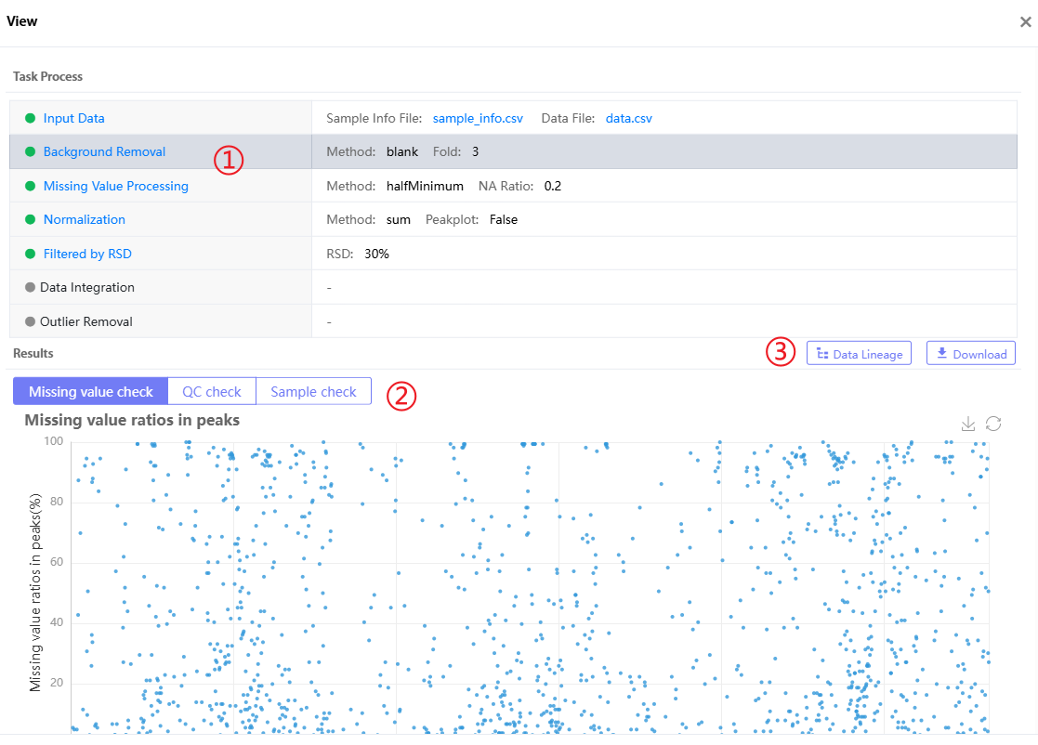
Figure 8.6 Background Removal results page
On each result page of data cleaning (except Data Integration and Outliers Removal), for each of the four analysis steps, TraceMetrix will generate three online result displays: 'Missing value check', 'QC check' and 'Sample check'.
In the 'Missing value check', we counted the missing ratio of each feature and each sample. As shown in the figure below, when no missing value processing is performed, there are different proportions of missing values ​​in both samples and features:
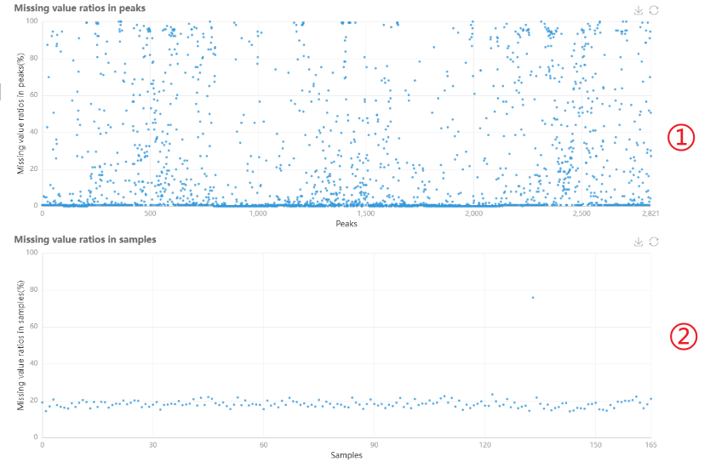
Figure 8.7 Background Removal results 'Missing value check' page
existIn 'QC check', we show the metabolic abundance of each QC sample through a box plot (top left), and also count the RSD distribution and proportion of each feature/peak, and also provide a correlation heat map of all QC samples
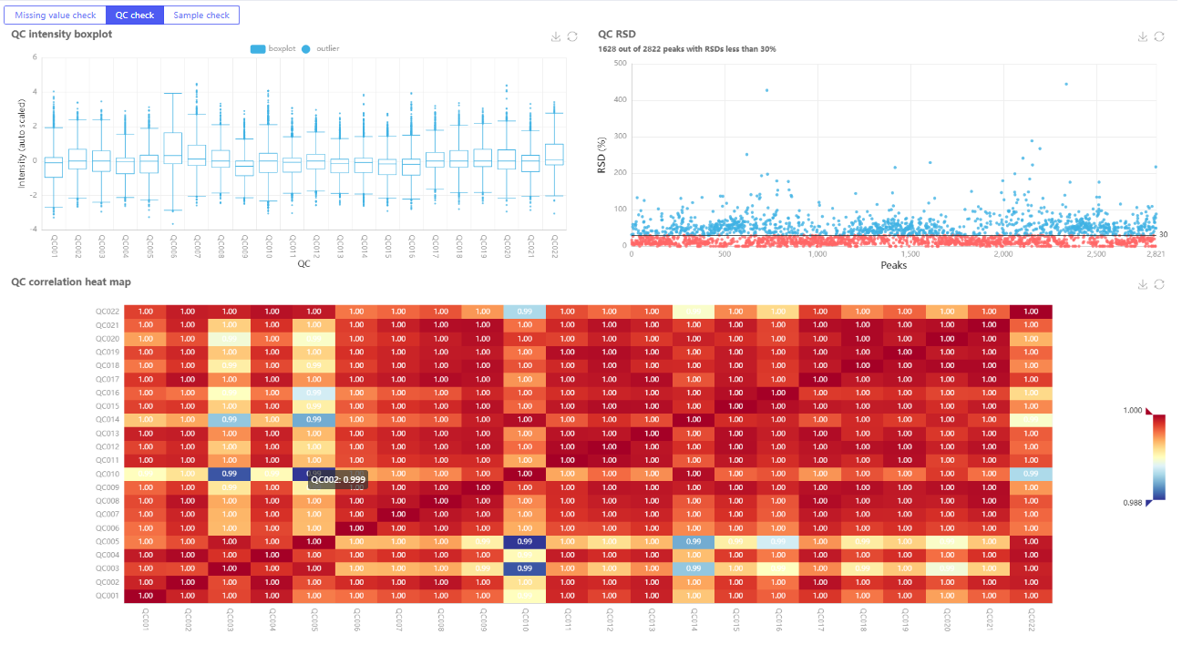
Figure 8.9 Background Removal results 'QC check' page

existIn 'Sample check', we counted the RSD distribution and proportion of each feature/peak of all samples
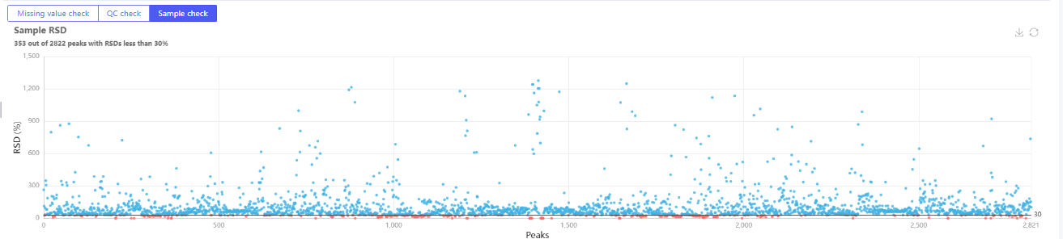
Figure 8.10 Background Removal results 'QC check' page
In addition, click on the③'Data lineage' and 'Download' can generate data traceability for this analysis step and download the result file to the local computer respectively:
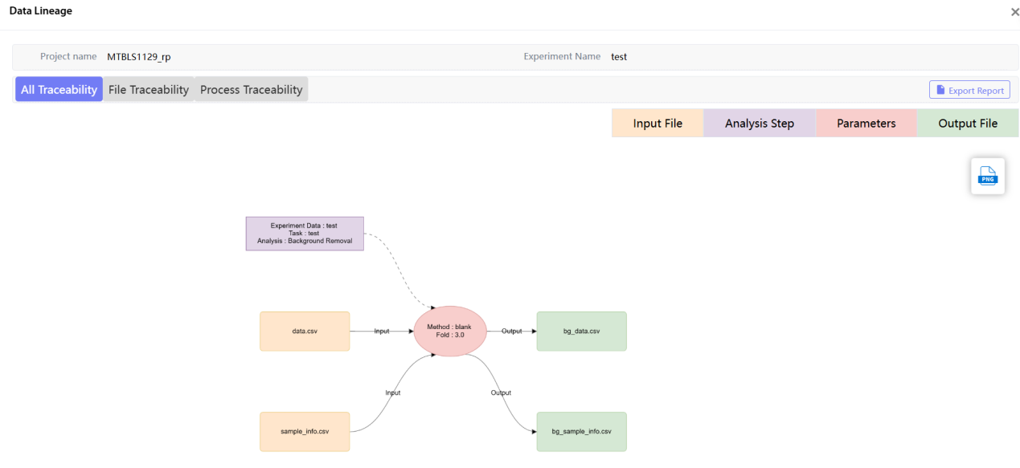
Figure 8.11 Background Removal result tracing
When you need toBackground Removal" results interface for the next step of analysis, you can directly hover the mouse over the "Background Removal" On the right side, click "Create next step" to jump to the data cleaning analysis page
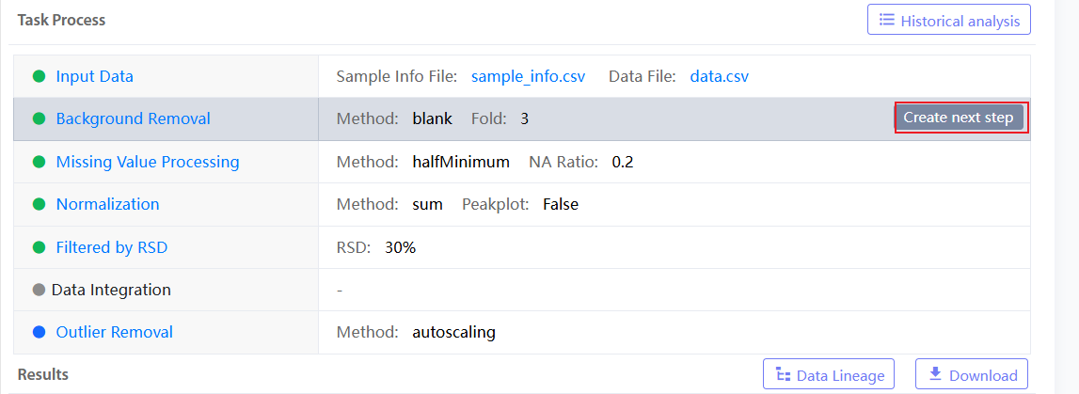
Figure 8.12 Background Removal result page Next analysis button

8.2. Missing Value Processing
The next step of Background Removal analysis is Missing Value Processing, which removes and fills NA values ​​in the two-dimensional data to ensure that subsequent statistical analysis does not report errors.
Parameter Description:
- NA ratio: NA ratio, generally the missing ratio of NA in each peak in all samples. For example, if the missing ratio of a peak in all samples exceeds 20%, the peak will be deleted.
- Method: NA filling method, including more than ten methods such as min, halfmin, median, etc., among which the commonly used methods are halfMinimun and randomForest (time-consuming).
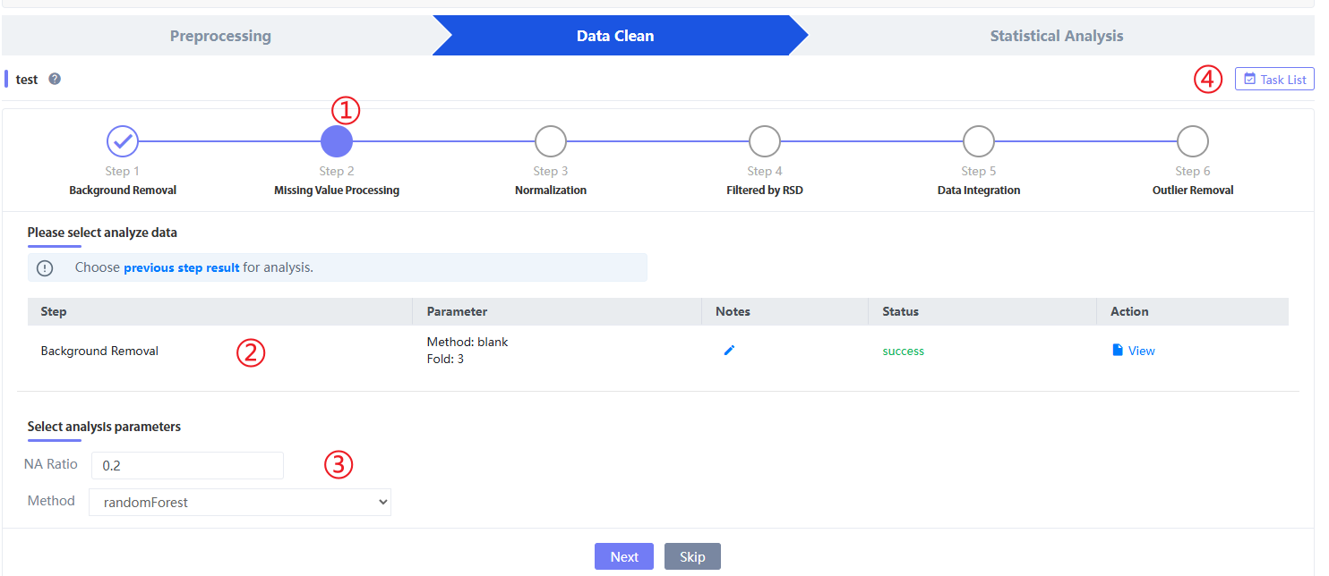
Figure 8.13 Missing Value Processing analysis and parameter selection
Click "previous step result" to select the previous step result for analysis. You can select different analysis results to proceed to the next step
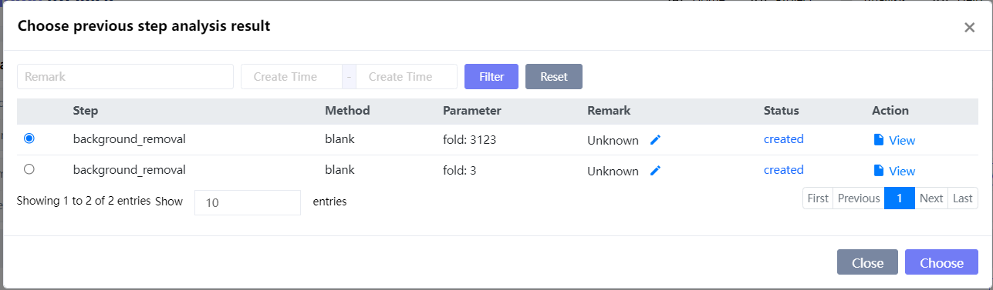
Figure 8.14 Select the result of the previous analysis step
After clicking "Next", jump to the next step.Missing Value Processing" After selecting the parameter page, there will be a status bar in the middle, which is the status bar in Figure 8.13②At this time, Status is 'success', that is, "Missing Value Processing"The analysis has been run successfully. Click 'view' or 'Task List' in the upper right corner to jump to the result page.exist“Missing Value ProcessingResults Page, TraceMetrix will generate three online result displays: 'Missing value check', 'QC check' and 'Sample check'.
In the 'Missing value check', we counted the missing ratio of each feature and each sample. As shown in the following figure, when the missing value processing is performed, there is no missing situation for both samples and features:
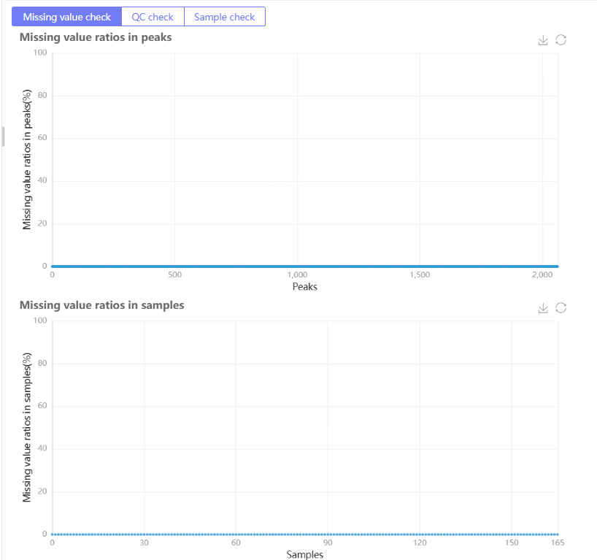
Figure 8.15 Missing Value Processing results 'Missing value check' page
In 'QC check', we show the metabolic abundance of each QC sample through a box plot (top left), and also count the RSD distribution and proportion of each feature/peak, and also provide a correlation heat map of all QC samplesexistIn 'Sample check', we counted the RSD distribution and proportion of each feature/peak of all samples
In addition, click 'Data lineage' and 'Download' in the result page to generate the data traceability of the analysis step and download the result file to the local computer respectively:
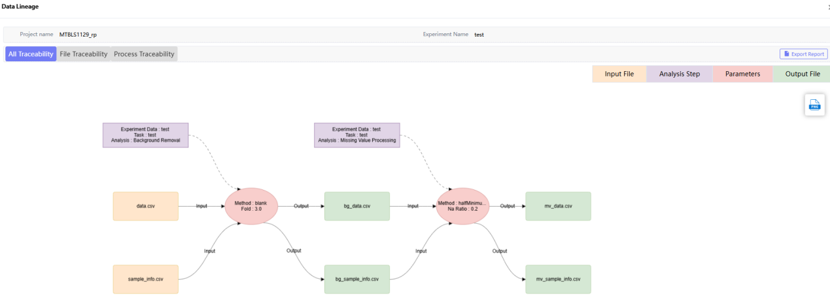
Figure 8.16 Missing Value Processing result traceability
When you need toMissing Value Processing" results interface for the next step of analysis, you can directly hover the mouse over the "Missing Value Processing"On the right, click "Create next step" to jump to the next analysis page
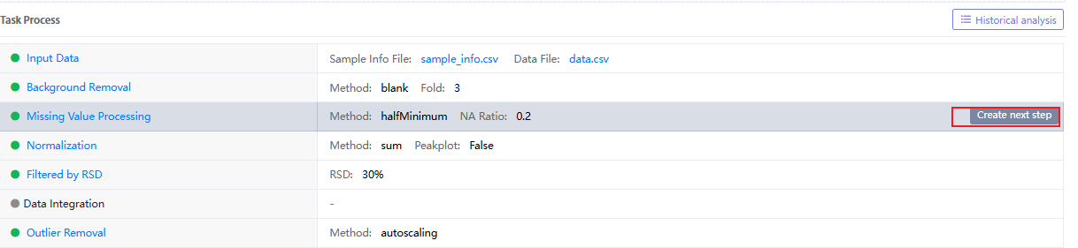
Figure 8.17 Next step analysis button on the Missing Value Processing result page

8.3. Normalization
The next analysis method for Missing Value Processing is Normalization, which is designed to normalize the data. Select the analysis parameters:
Parameter Description:
- peakplot: whether to draw a comparison chart for each peak before and after normalization (time-consuming);
- method: Normalization method, including sum (sum of peak areas), median (median of peak areas), and QC_SVR based on QC samples (requires an injection order column in the sample information table, with the column name "injection.orders").
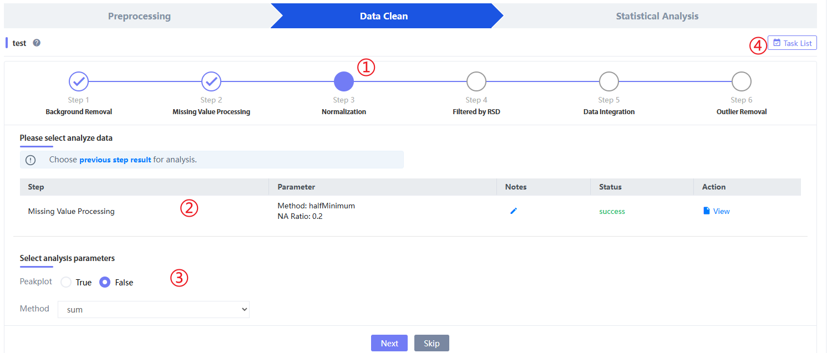
Figure 8.18 Normalization analysis and parameter selection
Click "previous step result" to select the previous step result for analysis. You can select different analysis results to proceed to the next step
Figure 8.19 Selection results
After clicking "Next", jump to the next step.Filtered by RSD" After selecting the parameter page, there will be a status bar in the middle, which is the status bar in Figure 8.13②At this time, Status is 'success', that is, "Normalization"The analysis has been run successfully. Click 'view' or 'Task List' in the upper right corner to jump to the result page.exist“NormalizationResults Page, TraceMetrix will generate three online result displays: 'Missing value check', 'QC check' and 'Sample check'.
In 'Missing value check', we counted the missing ratio of each feature and each sample.existIn 'QC check', we show the metabolic abundance of each QC sample through a box plot (upper left), and also count the RSD distribution and proportion of each feature/peak, and also provide a correlation heat map of all QC samples. As shown in the figure, after normalization, the means of each QC sample are basically equal:
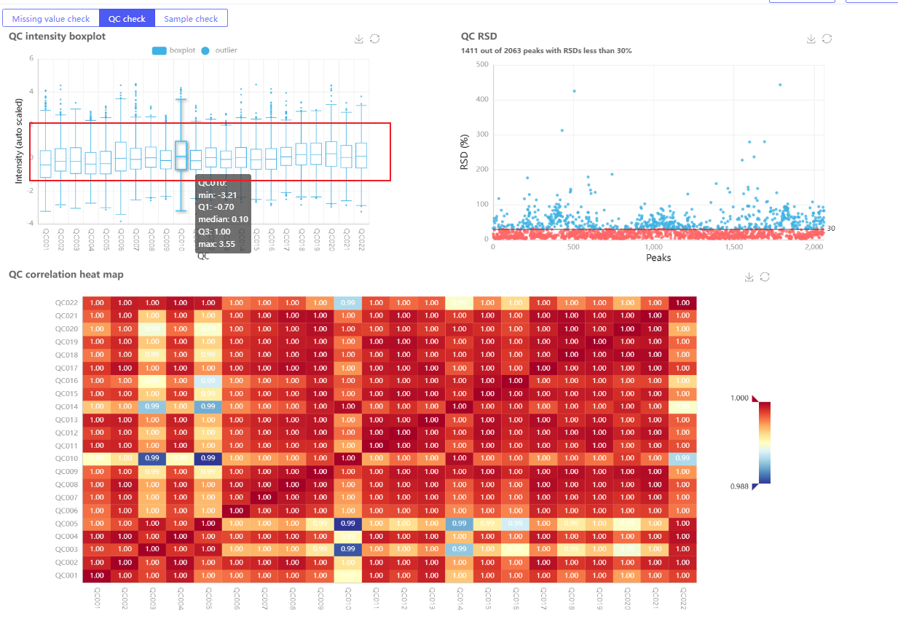
Figure 8.20 Normlization'QC check'page

In 'Sample check', we counted the RSD distribution and proportion of each feature/peak of all samples.
Alternatively, click③'Data lineage' and 'Download' can generate data traceability for this analysis step and download the result file to the local computer respectively:
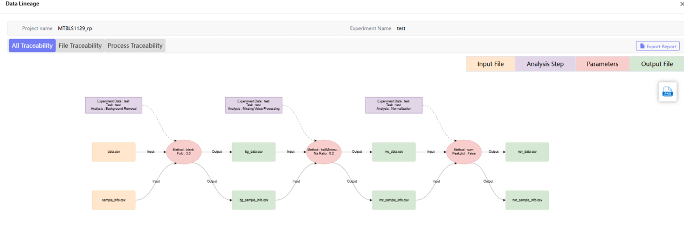
Figure 8.21 Normlization Result traceability
When you need to proceed to the next step of analysis from the "Normlization" result interface, you can directly hover your mouse to the right of "Normlization" in Task Process and click "Create next step" to jump to the next step of analysis page.
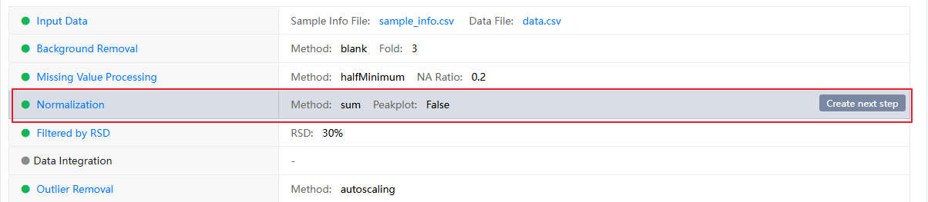
Figure 8.22 NormlizationNext step analysis button on the results page

8.4. Filtered by RSD
The next analysis method under Normalization is: Filtered by RSD, which is designed to remove the RSD threshold peaks that exceed the QC in the quantitative peaks. The analysis parameters are selected as follows:
Parameter Description: RSD (Relative Standard Deviation)
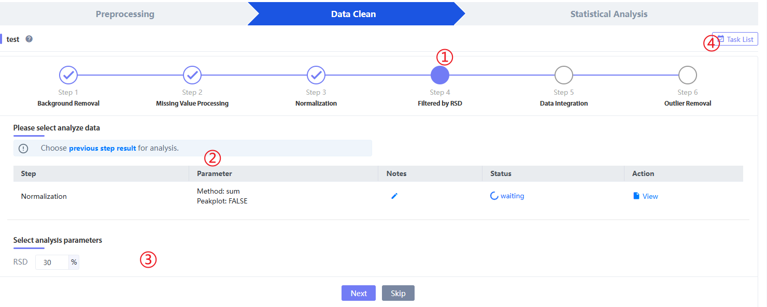
Figure 8.23 ​​Filtered by RSD analysis and parameter selection page

Click "previous step result" to select the previous step result for analysis. You can select different analysis results to proceed to the next step, and click "view" or "task list" to view all analysis parameters and results.
After clicking "Next", jump to the next step.Data Integration" After selecting the parameter page, there will be a status bar in the middle, which is the status bar in Figure 8.13②At this time, Status is 'success', that is, "Filtered by RSD"The analysis has been run successfully. Click 'view' or 'Task List' in the upper right corner to jump to the result page.exist“Filtered by RSDResults Page, TraceMetrix will generate three online result displays: 'Missing value check', 'QC check' and 'Sample check'.
In 'Missing value check', we counted the missing ratio of each feature and each sample.existIn 'QC check', we use box plots to show the metabolic abundance of each QC sample (upper left), and also count the RSD distribution and proportion of each feature/peak, and provide a correlation heat map of all QC samples. As shown in the figure, after Filtered by RSD, the RSD of the peaks of each QC sample is less than the threshold:
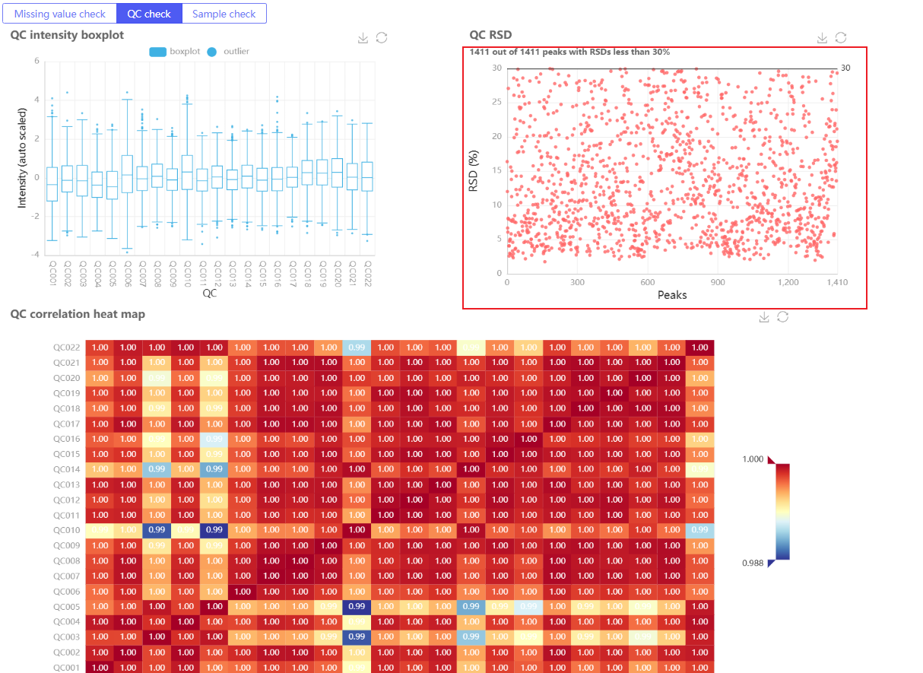
Figure 8.24 Filtered by RSD'QC check'page

existIn 'Sample check', we counted the RSD distribution and proportion of each feature/peak of all samples.
Alternatively, click③'Data lineage' and 'Download' can generate data traceability for this analysis step and download the result file to the local computer respectively:
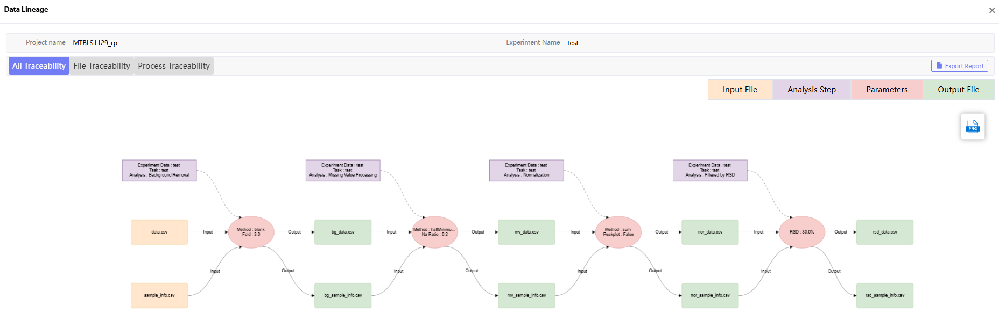
Figure 8.25 Filtered by RSD Result traceability
When you need to proceed to the next step of analysis from the "Filtered by RSD" result interface, you can directly hover the mouse to the right of "Filtered by RSD" in Task Process and click "Create next step" to jump to the next step of analysis page.
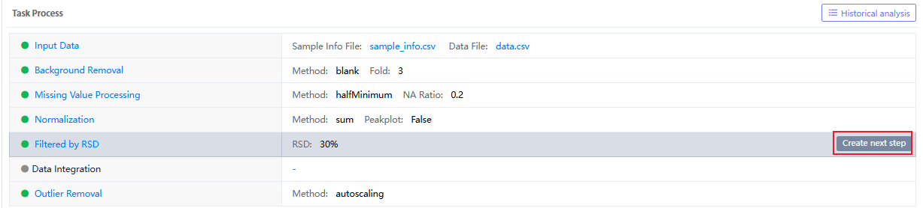
Figure 8.26 Filtered by RSD Next step analysis button on the results page

8.5. Data Integration
The next analysis method after Filtered by RSD is Data Integration, also known as batch correlation. If there are multiple batches of data, that is, data not obtained in the same mass spectrometry experiment, batch correlation needs to be performed through Data Integration. The analysis parameters are as follows:
Parameter description: Currently, only batch correction based on the average median value of the peak is provided, including intra-batch correction and inter-batch correction.
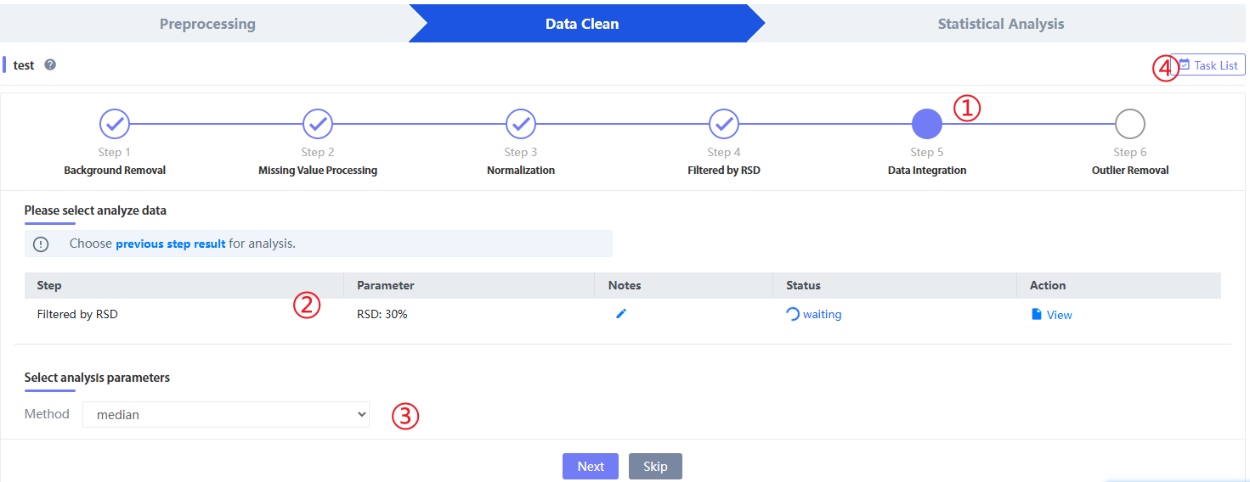
Figure 8.27 Data Integration analysis and parameter selection

8.6. Outlier Removal
The next analysis step of Data Integration is "Outliers Removal", which aims to identify abnormal samples in the sample. Usually, we use the results of "Outliers Removal" to detect whether there are abnormal samples in the sample online, that is, whether there are sample points outside the execution interval in the PCA graph in the figure. If so, combine other information, such as baseline information, experimental process processing information, etc. to comprehensively judge whether the sample is an abnormal point. If so, delete it and re-incorporate it into the data cleaning process. Select the analysis parameters as follows:
Parameter Description:
- method: data normalization method.
- CI: Confidence interval, the confidence interval can be set freely, the default is 95%.
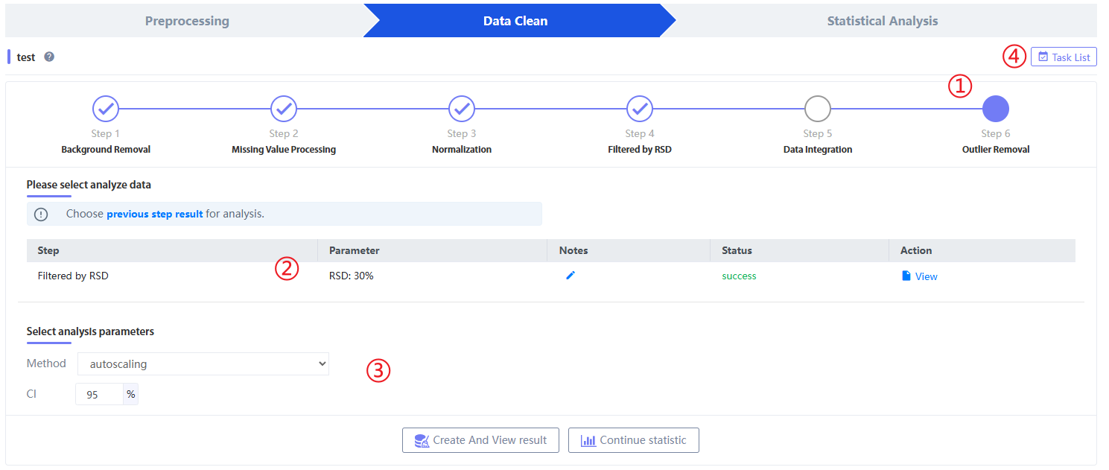
Figure 8.28 Outlier Removal analysis and parameter selection

Click "previous step result" to select the previous step result for analysis. You can select different analysis results to proceed to the next step, and click "view" or "task list" to view all analysis parameters and results. Click "continue statistic" to perform statistical analysis.
After clicking "Create And View results" and jumping to the result page under the task.exist“Outlier RemovalResults Page, TraceMetrix will use hottling T2 and the dot graph to form an outlier detection graph, as shown in the figure8.29③As shown, points outside the confidence interval may be considered outliers:
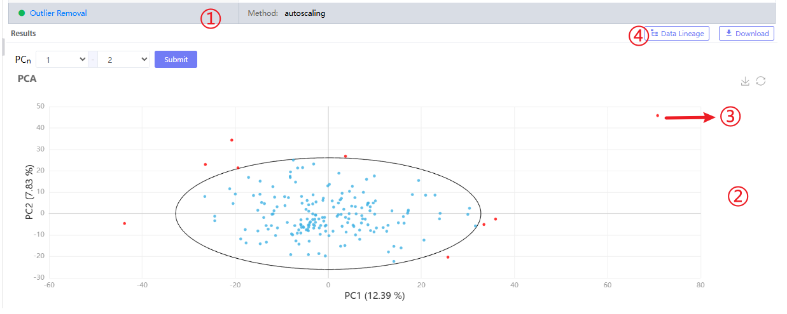
Figure 8.29 Outlier Removal results page
In addition, click on the③'Data lineage' and 'Download' can generate data traceability for this analysis step and download the result file to the local computer respectively:
Figure 8.30 Outlier Removal result traceability

Statistical analysis
Click "statistic" on the Analysis page to enter the statistical analysis module. The statistical analysis functions include: univariate statistics (including two-sample comparison and multi-sample comparison); multivariate statistics (including PCA, PLS-DA, OPLS-DA).
Click choose (①) After selecting a project, the analysis tasks in the project are displayed. For a new project, click "Create new experiment" (②) to create a new statistical analysis or select an existing “Experiment data” (③) and fill in Task Name (it cannot be the same as the task name under the analysis module under the experimental data), click "task list" to select and jump to the task list of the selected experiment name.

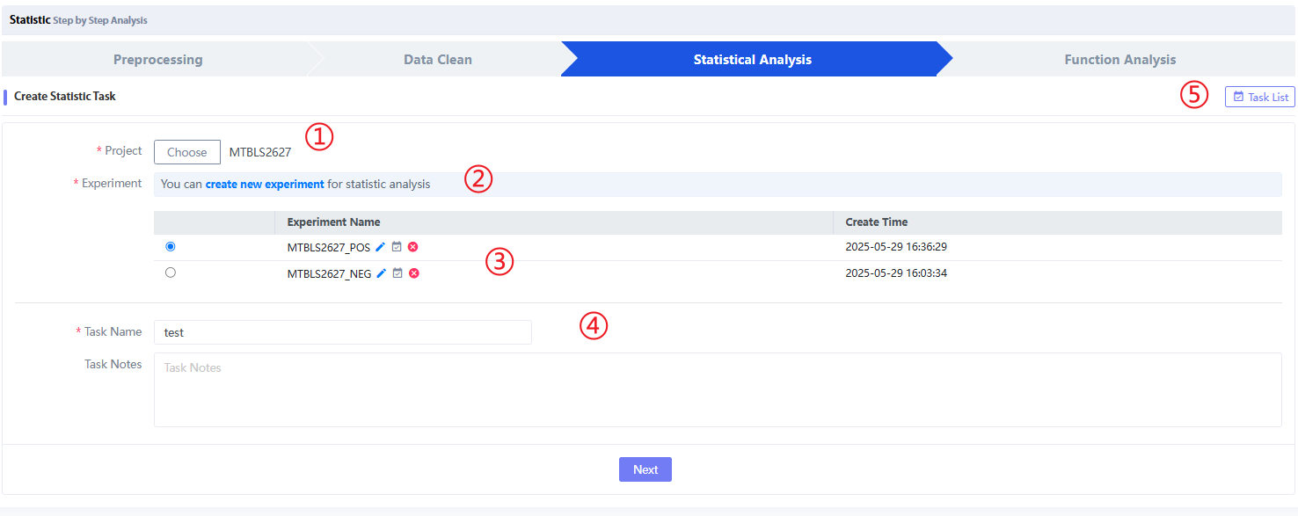
Figure 9.1 Statistic analysis task
Select the project name and click "Next" to enter the statistics page. All current statistical analysis methods are on this page, and each analysis method is①) have no correlation and exist independently.

9.1. Univate Analysis

In order to establish a traceability relationship with the preprocessing and data cleaning modules, we provide two data interfaces in the "Data file" mentioned in the statistical analysis method selection: 'Upload' is to upload the metabolic abundance matrix from the local (.csv format, no missing values), and 'Data Clean' comes from the "Data Clean" module in the experiment data. After clicking it, you can select the analysis step results under different tasks. Select one of them as the metabolic abundance matrix for input analysis and upload the corresponding sample information file ("Sample File" is a sample information table containing columns such as 'sample.name' and 'groups').
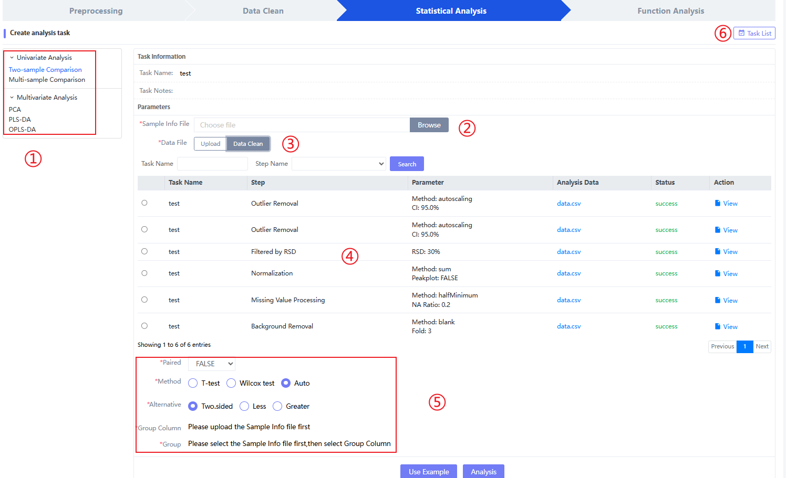
Figure 9.2 Statistic analysis method selection

Figure 9.2⑤This is the parameter input page for double sample comparison. This step requires the user to perform statistical analysis on the samples between the two groups. Common methods include student's t test and non-parametric test. If the normal distribution of the data cannot be determined, select 'Auto' in 'Method' for automatic determination. The parameter 'Paired' is whether the two groups of samples correspond one to one in quantity. If not, select FALSE. The parameter 'Alternative' is whether the double-ended or single-ended double-sample test is used. The parameter 'Group Column' is the column containing group information in the uploaded sample information file, which is defined and selected by the user. The parameter 'Group' is the two groups that need to be compared specifically (for example, case vs control), which can be determined by '➕'Compare more than two groups simultaneously.
When all parameters are selected, click "Analysis" at the bottom to submit and wait for the analysis results.①The parameters selected for the previous Two-sample comparsion,②It is the analysis status. If the analysis is successful, it is the analysis result.⑥Two-sample comparison analysis history for the current task.
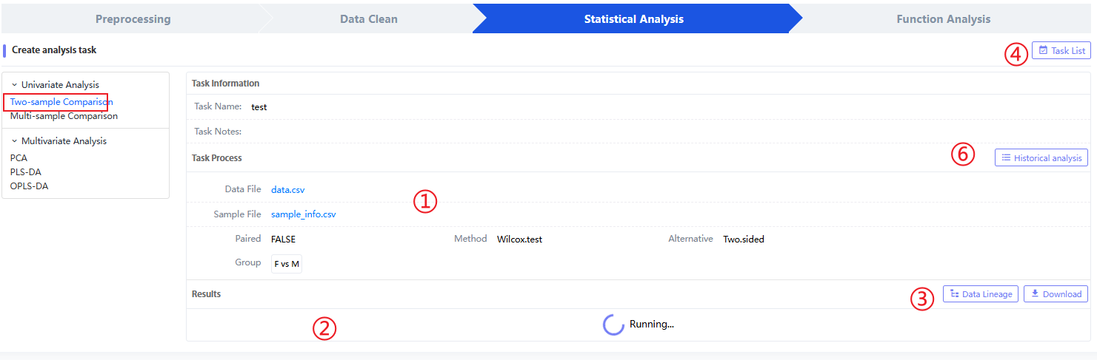
Figure 9.4 Two-sample comparison analysis status
Click④Enter the task list result page of all the current "Experiment data", click 9.5 to enter the selected task, click "Two-sample comparison" in "Task Process" to enter the Two-sample comparison result page,As shown in the figure, the results of the comparison between the two groups include the log2Fold Change value between the two groups, pvalue, and the value of pvalue after FDR and Bonf correction..Note that some pvalues ​​are too small to show the full value, so they are displayed as 0.0000 on the Web, and the true value is much less than 0.01.Figure 9.5⑥It is a tag in the Tag system, which is used by users to mark and edit the indicators of interest in the analysis results. It is generally used to screen differential metabolites together with the indicators in the subsequent OPLS-DA analysis.③Each row in the "Compound" column in the data provides a box plot between the two groups, which is used to determine the mean of the two groups at any time.
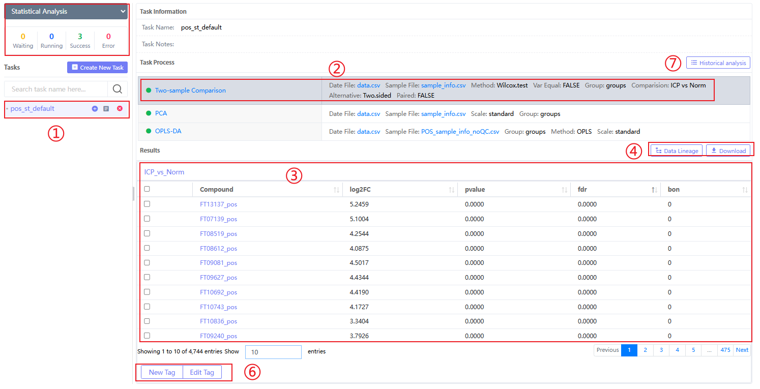
Figure 9.5 Two-sample comparison analysis status
Figure 9.4③and Figure 9.5④Both'Data lineage' and 'Download' can generate data traceability for this analysis step and download result files to local. As shown in the figure, the red box above represents the Filtered by RSD result from the data cleaning module, and the red box below represents the sample file re-uploaded by the user, thus connecting different modules in series.
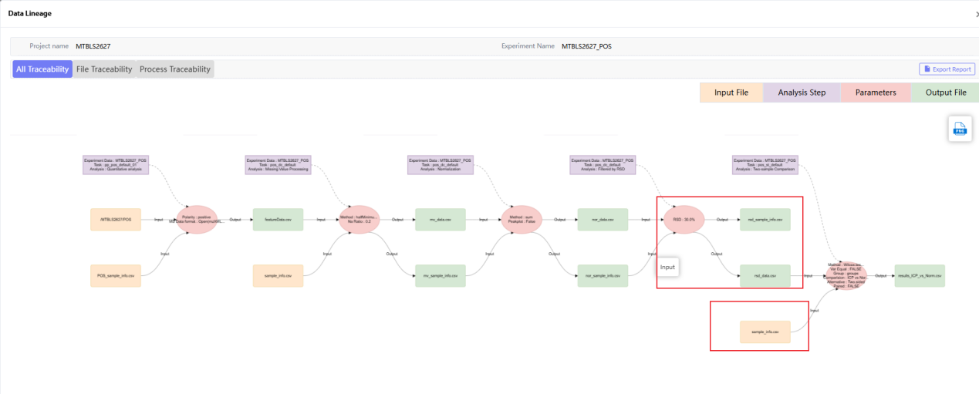
Figure 9.6 Two-sample comparison traceability

When the user needs to compare multiple samples, click "Multi-sample Comparison"After that, enter the analysis step page to select parameters, where "Select File": select the source of the analysis file, including direct 'Upload' and 'data clean' results from the same "experiment data", click "data clean" to select the data cleaned file for analysis, enter keywords and select search (as shown below). "Sample File" is a sample information table containing columns such as 'sample.name', 'classes', and 'groups'. "Data File" is a table without NA. "method": method for multiple group comparisons; "Group Column": column name containing group information in 'sample File'; "Groups": group content that requires multiple group comparisons, generally more than three groups. If there are only two groups, it will automatically become a two-sample comparison.
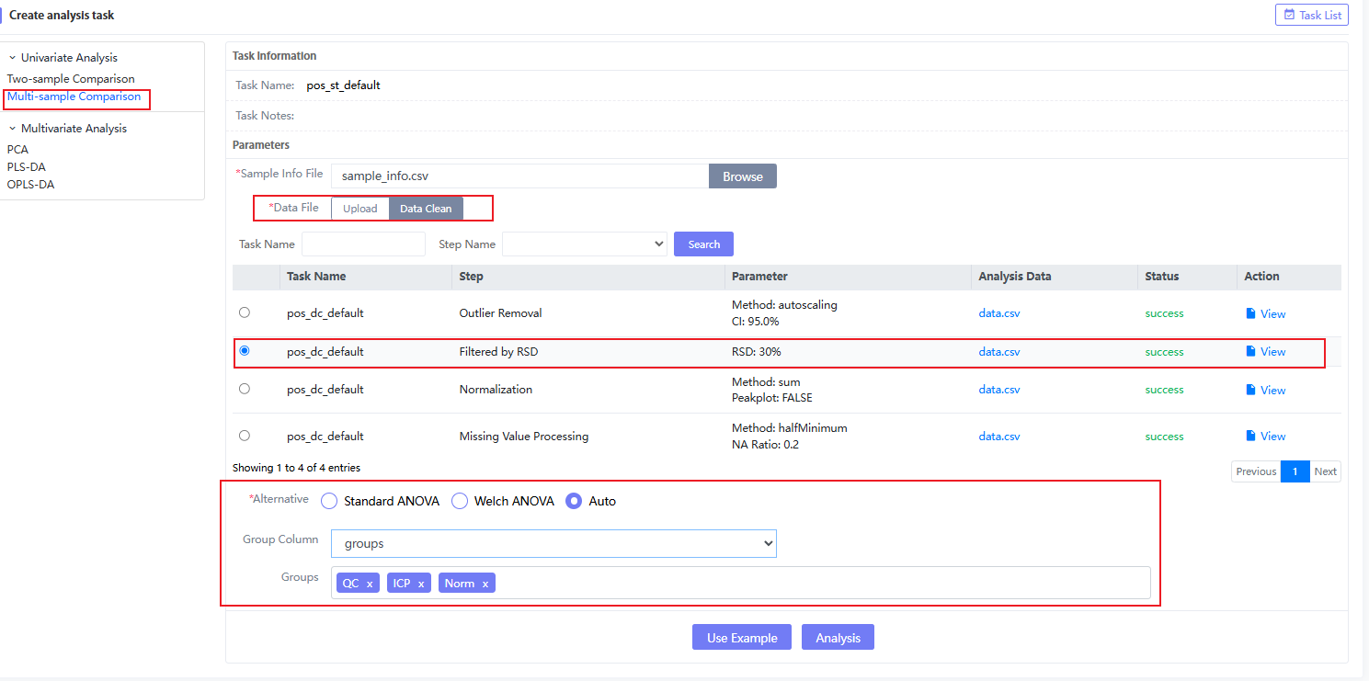
Figure 9.7Multi-sampleComparsion parameter selection
EnterMulti-sampleComparsion result page,As shown in the figure, the results of multiple group comparisons include the pvalues ​​between multiple groups..Note that some pvalues ​​are too small to show the full value, so they are displayed as 0.0000 on the Web, and the true value is much less than 0.01.Figure 9.8⑦It is a tag in the Tag system, which is used by users to mark and edit the indicators of interest in the analysis results. It is generally used to screen differential metabolites together with the indicators in the subsequent OPLS-DA analysis.③Each row in the "Name" column provides a box plot between multiple groups and an ANOVA analysis process, which is used to determine the mean values ​​of multiple groups and the statistical results between any two groups at any time.

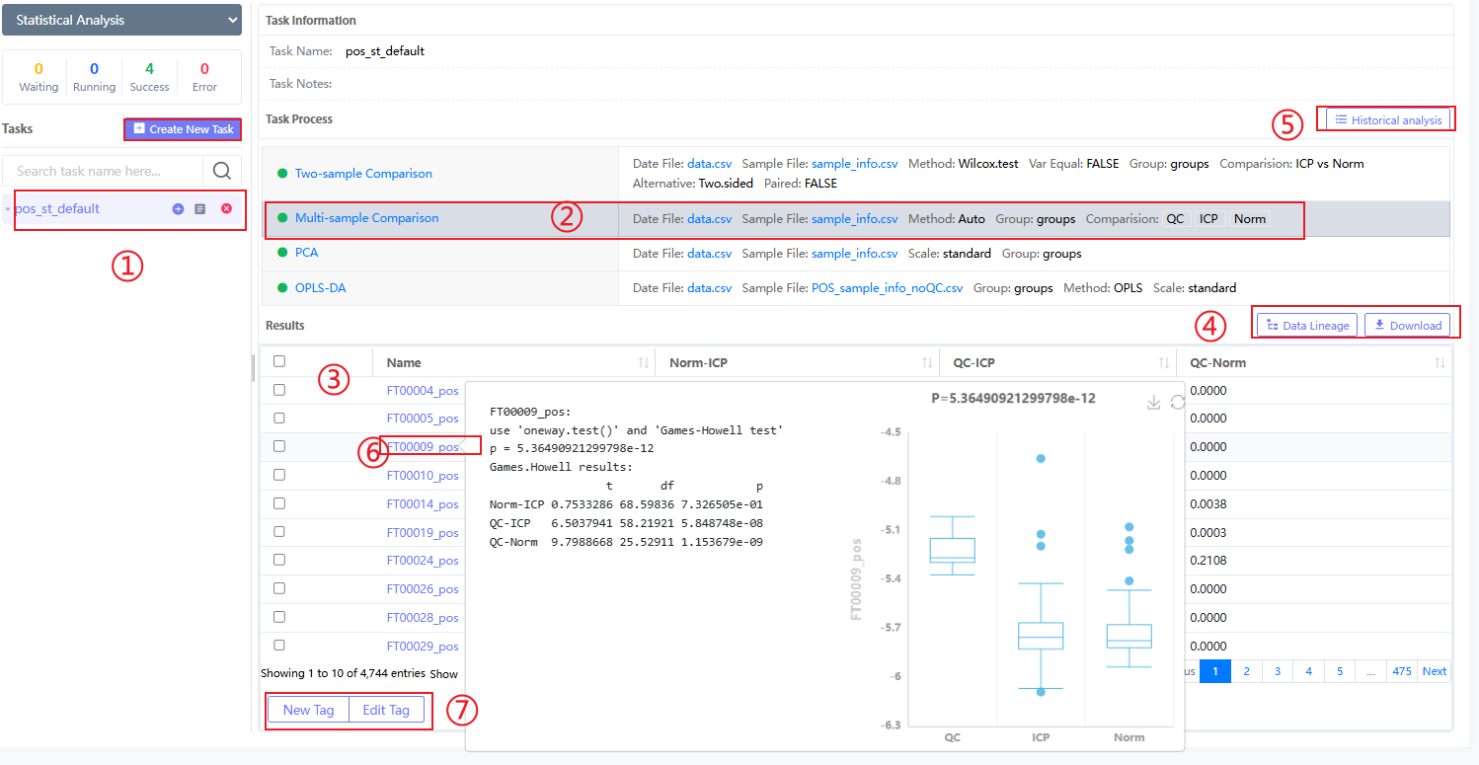
Figure 9.8Multi-sampleComparsion results page
Figure 9.10④Both'Data lineage' and 'Download' can generate data traceability for this analysis step and download result files to local. As shown in the figure, the red box above represents the Filtered by RSD result from the data cleaning module, and the red box below represents the sample file re-uploaded by the user, thus connecting different modules in series.
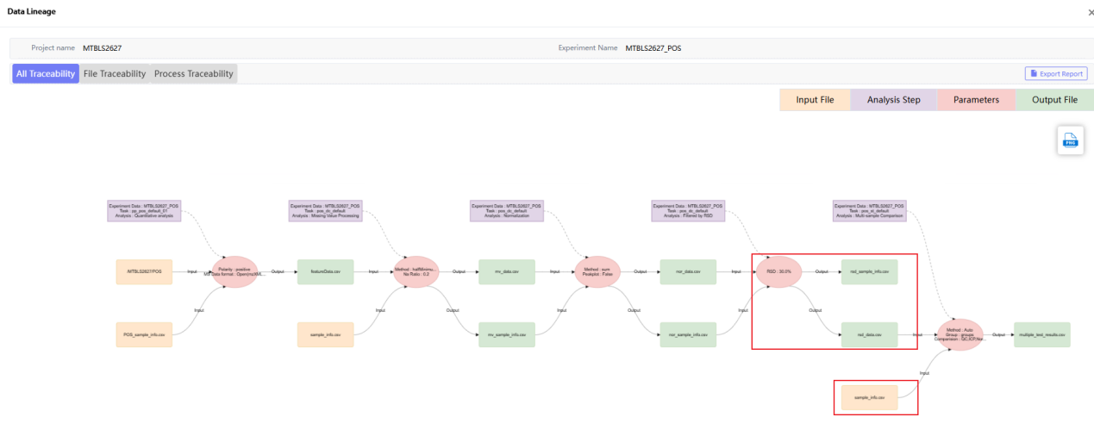
Figure 9.10 Multi-sampleComparsion data traceability

9.2. Multivariate Analysis
Multivariate AnalysisIncluding PCA analysis and PLS-DA and OPLS-DA analysis.
When the user wants to reduce the dimension of high-dimensional metabolomics data and observe the clustering of different samples, click statistical analysis—PCA to enter the PCA analysis interface. The column name containing group information in 'sample File'. "Select File": Select the source of the analysis file, including direct 'Upload' and 'data clean' results from the same "experiment data". Click "data clean" to select the data cleaned file for analysis, enter keywords and select search (as shown below). "Sample File" is a sample information table containing columns such as 'sample.name', 'classes', and 'group'. "Data File" is a table without NA. method: matrix data normalization method.
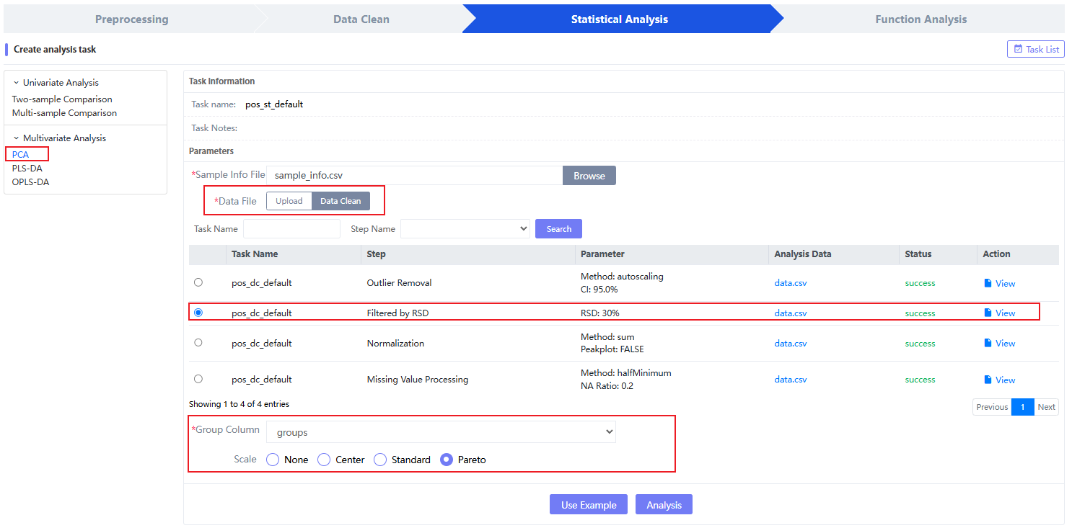
Figure 9.11 PCA Parameter selection
EnterPCAThe result page, Figure 9.12③It provides a choice of PCA between 1-4 dimensions. After the user enters the dimensions they want to compare, click 'Submit' to generate it.
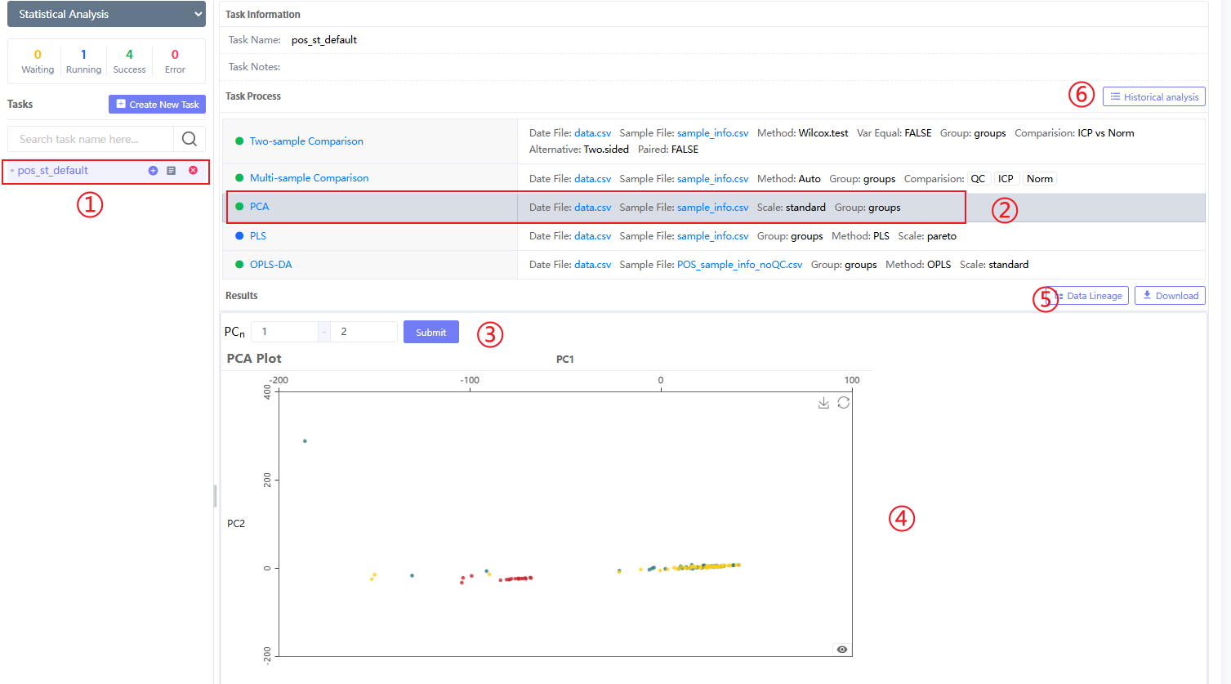
Figure 9.12 PCA Results Page
Figure 9.10④for'Data lineage' and 'Download' can generate data traceability for this analysis step and download result files to local. As shown in the figure, the red box above represents the Filtered by RSD result from the data cleaning module, and the red box below represents the sample file re-uploaded by the user, thus connecting different modules in series.
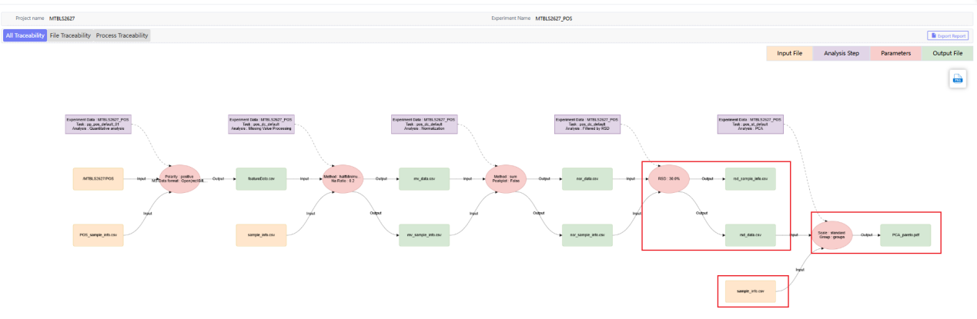
Figure 9.13 PCA Data traceability
PLS-DA analysis and OPLS-DA are commonly used multivariate statistical methods, and their main purpose is to classify samples and screen metabolites. The figure below shows the parameters of PLS-DA analysis: "Select File": Select the source of the analysis file, including direct 'Upload' and 'data clean' results from the same "experiment data", click "data clean" to select the data cleaned file for analysis, enter keywords and select search (as shown below). "Sample File" is a sample information table containing columns such as 'sample.name', 'classes', and 'group'. "Group Column": The name of the column containing group information in 'sample File'. "ScaleC": Matrix data normalization method. Note that the PLS-DA method allows the group information of samples to exceed 2 groups!

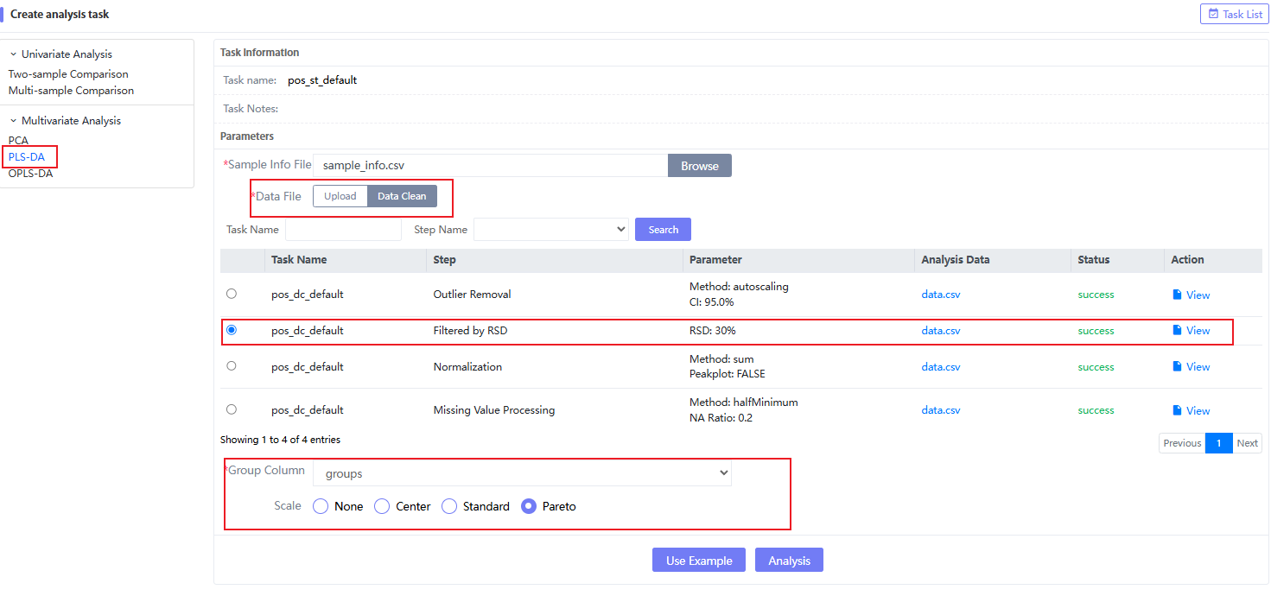
Figure 9.14 PLS-DA Parameter
When the PLS-DA analysis is successful, you will enter the result page and get the specific PLS-DA results. The result part consists of two groups, one of which is the visual graph: score graph, load graph, model stability graph and VIP distribution graph (as shown in Figure 9.15).
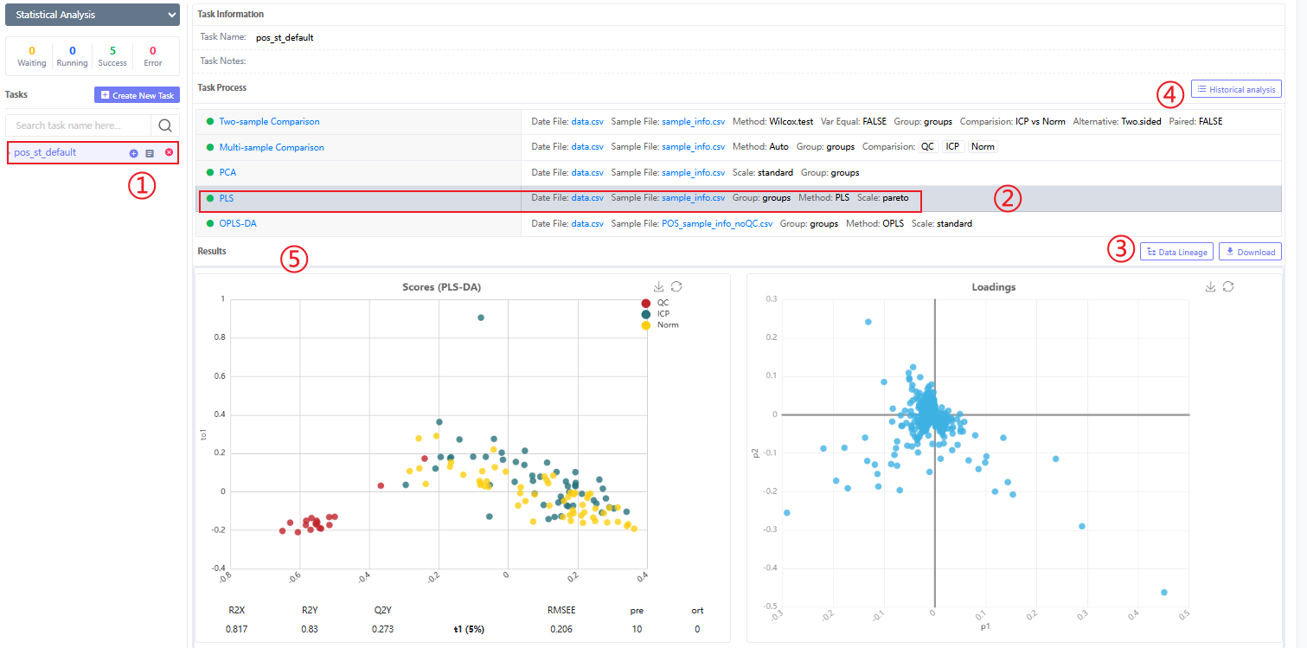
Figure 9.15 PLS-DA Results Page 1
On the other hand, the VIP distribution table is shown in Figure 9.16.②It is a tag in the Tag system, which is used by users to mark and edit the indicators of interest in the analysis results. It is generally used to screen differential metabolites together with the indicators in the previous two-sample comparison analysis.
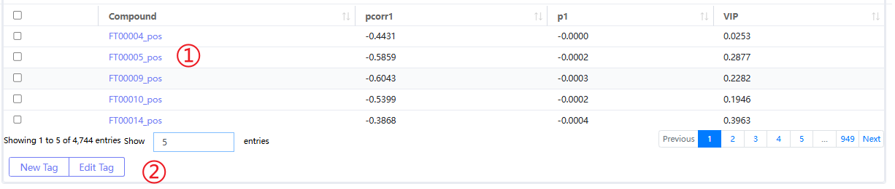
Figure 9.16 PLS-DA Results Page 2
Figure 9.14④Both'Data lineage' and 'Download' can generate data traceability for this analysis step and download result files to local. As shown in the figure, the red box above represents the Filtered by RSD result from the data cleaning module, and the red box below represents the sample file re-uploaded by the user, thus connecting different modules in series.
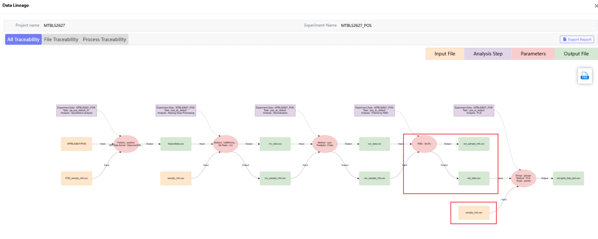
Figure 9.17 PLS-DA Data traceability
The figure below shows the parameters of OPLS-DA analysis: "Select File": Select the source of the analysis file, including direct 'Upload' and 'data clean' results from the same 'experiment data'. Click 'data clean' to select the data cleaned file for analysis, enter keywords and select search (as shown below). "Sample File" is a sample information table containing columns such as 'sample.name', 'classes', and 'group'. "Group Column": The name of the column in 'sample File' that contains group information. "ScaleC": Matrix data normalization method.Note that the OPLS-DA method only allows the sample group information in the "Sample File" to be only 2 groups!
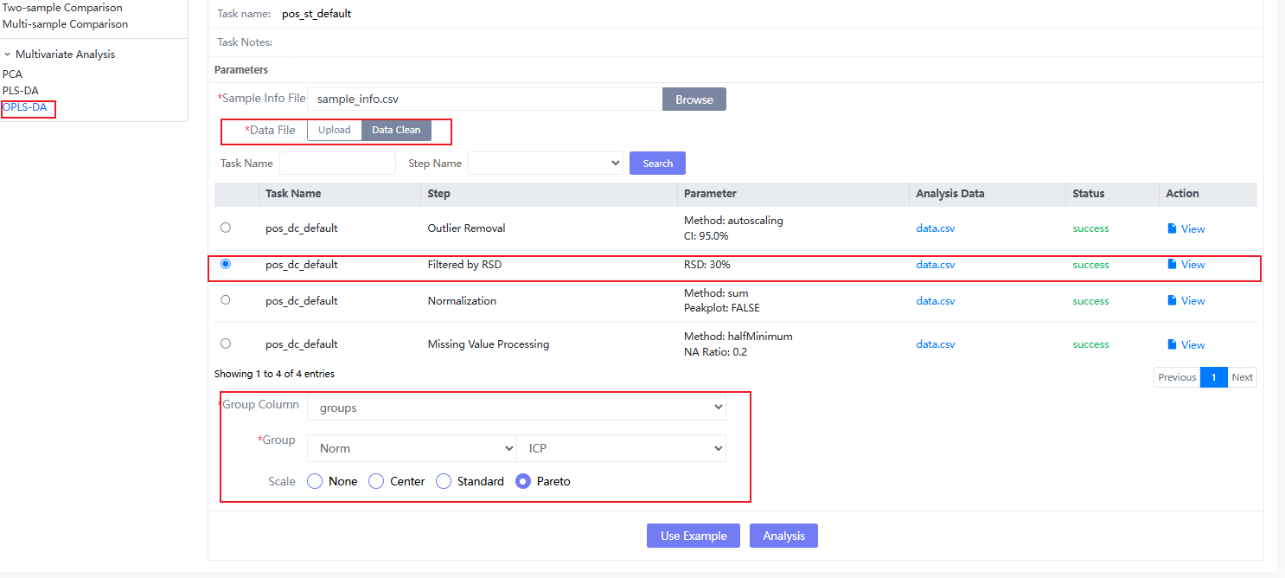
Figure 9.18 OPLS-DA Parameter selection
When the PLS-DA analysis is successful, you will get the specific PLS-DA results after entering the result page. The result section consists of two parts. One part is the visual graphics: score graph, load graph, model stability graph and VIP distribution graph (Figure 9.15). The other part is the VIP distribution table, Figure 9.16②It is a tag in the Tag system, which is used by users to mark and edit the indicators of interest in the analysis results. It is generally used to screen differential metabolites together with the indicators in the previous two-sample comparison analysis.④Both'Data lineage' and 'Download' can generate data traceability for this analysis step and download result files to local. As shown in the figure, the red box above represents the Filtered by RSD result from the data cleaning module, and the red box below represents the sample file re-uploaded by the user, thus connecting different modules in series.
Metabolite enrichment analysis; correlation analysis (including Pearson, Spearman, Kendall); linear regression (including simple linear regression and multivariate linear regression); Logistic regression (including binary logistic regression, unordered multi-classification logistic regression, ordered multi-classification logistic regression); survival analysis (including Kaplan-Meier method and COX proportional hazard regression).

Function analysis
Click “Function Analysis” on the Analysis page to enter the function analysis module. Functional analysis functions include: correlation analysis; linear regression analysis; logistic regression analysis; survival analysis and enrichment pathway analysis.
Click choose (①) After selecting a project, the analysis tasks in the project are displayed. For a new project, click "Create new experiment" (②) to create a new statistical analysis or select an existing “Experiment data” (③) and fill in Task Name (it cannot be the same as the task name under the analysis module under the experimental data), click "task list" to select and jump to the task list of the selected experiment name.

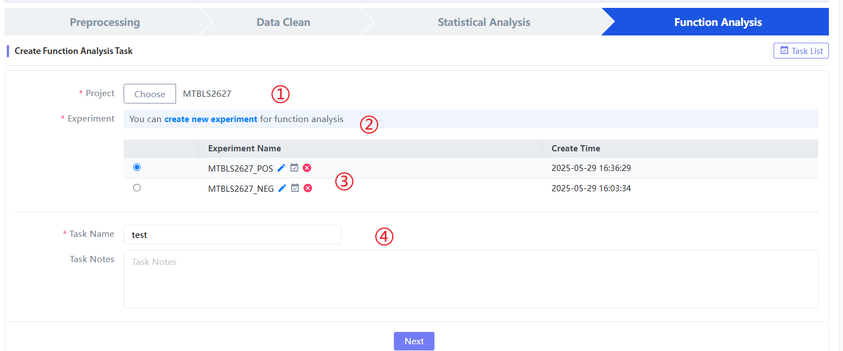
Figure 10.1 Statistic analysis task

10.1. Correlation Analysis
Correlation Analysis：In metabolic data analysis, correlation analysis is a commonly used statistical method, and its main purpose is to explore the correlation between metabolites and find metabolites with high correlation.Correlation AnalysisOn the analysis page,Tags are used to connect the analytical relationships in statistical analysis, so as to form a complete traceability of the four modules.; "Data File 1": Analysis file 1, the first column is the sample column, and each subsequent column is a metabolite column. If there is only one file, it is the correlation of metabolites within the file; "Data File 2": Analysis file 2, the first column is the sample column, and each subsequent column is a metabolite column. If there are two files, it is the correlation of metabolites between files; the row content of the two files must be consistent; "Method": correlation analysis method; "Alternative": used to determine whether the test result is one-sided (one-sided) or two-sided (two-sided). Usually, in the absence of clear a priori hypotheses, it is more common to use the default "two.sided" for two-sided tests. However, if the researcher has relevant field knowledge or specific hypotheses, an appropriate one-tailed test ("less" or "greater") can be selected to determine the directional difference in the mean.
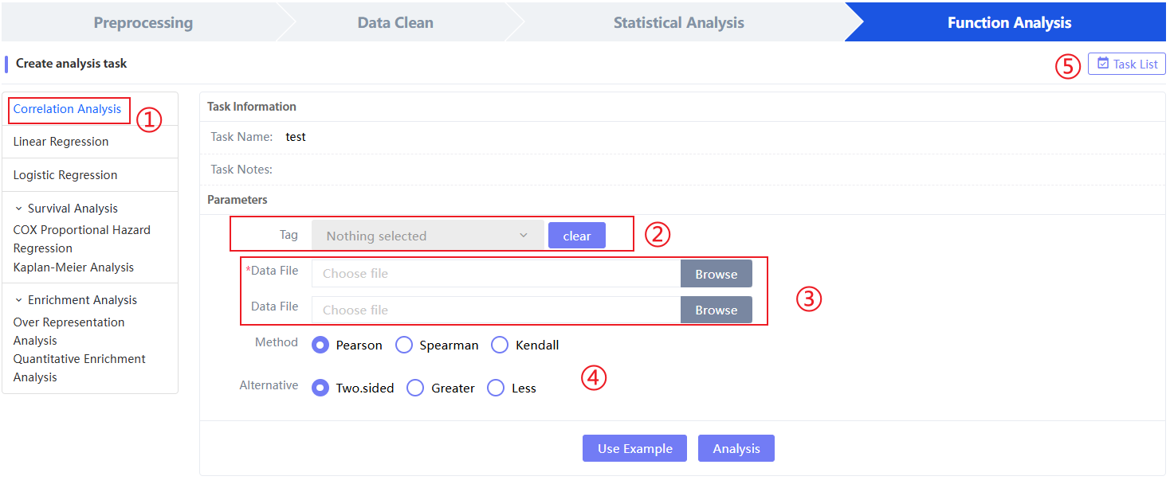
Figure 10.2 Correlation AnalysisParameter selection
whenCorrelation AnalysisAfter the analysis is successful, enter the result page and you will get the specificCorrelation AnalysisResults,The results section consists of two partial groups, a partial correlation table below④, including correlation values ​​and pvalues ​​between each pair; another part of the correlation visualization heat map is shown below⑤.

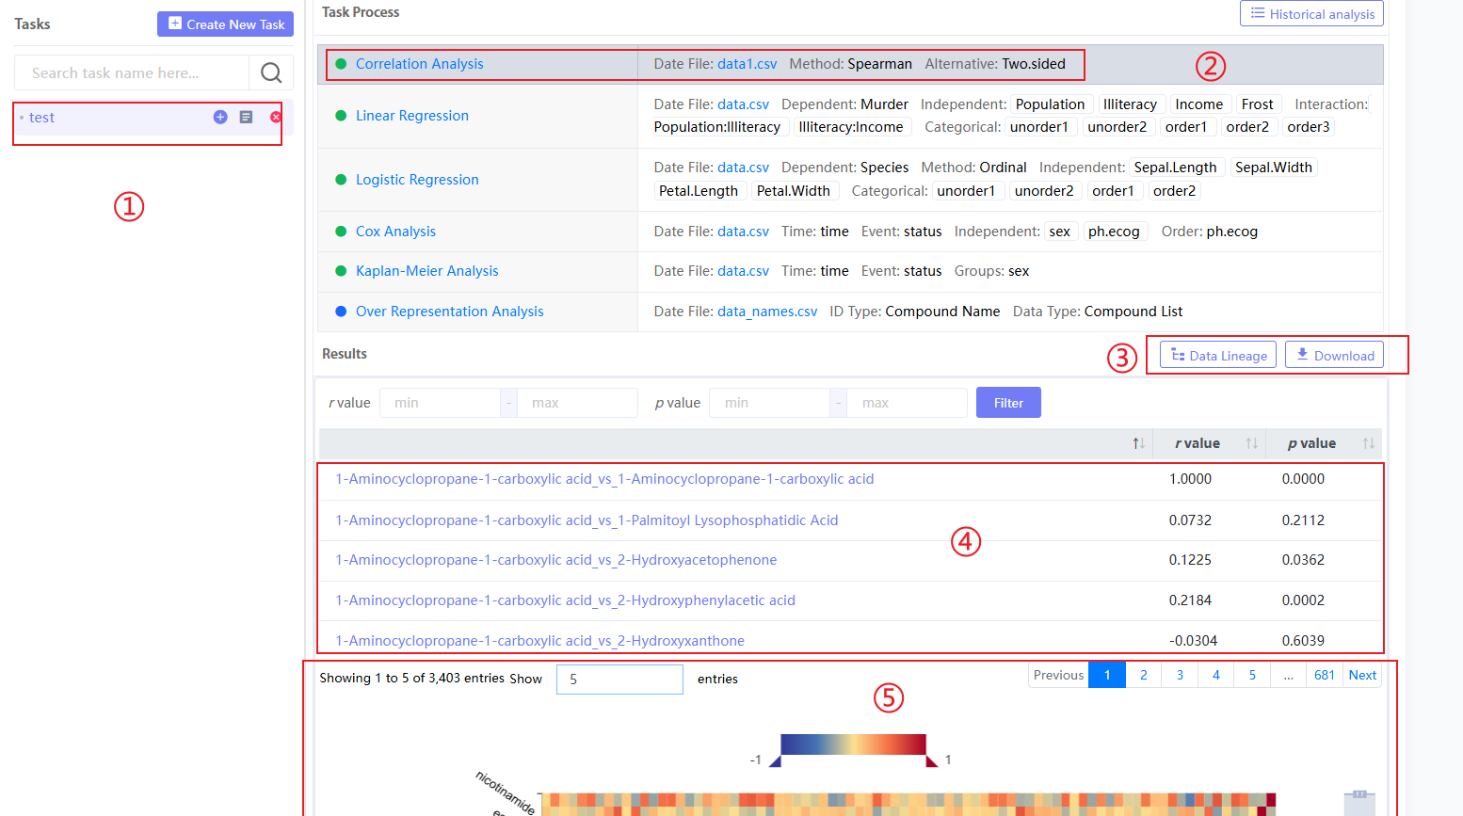
Figure 10.3 Correlation AnalysisParameter selection
Figure 10.3③Both'Data lineage' and 'Download' can generate data traceability for this analysis step and download the result file to the local computer respectively. If you select the tag generated in the statistical analysis before, it will be convenient to connect the statistical analysis modules in series. The following figure shows a separate analysis without using tags, so the traceability content generated is less:
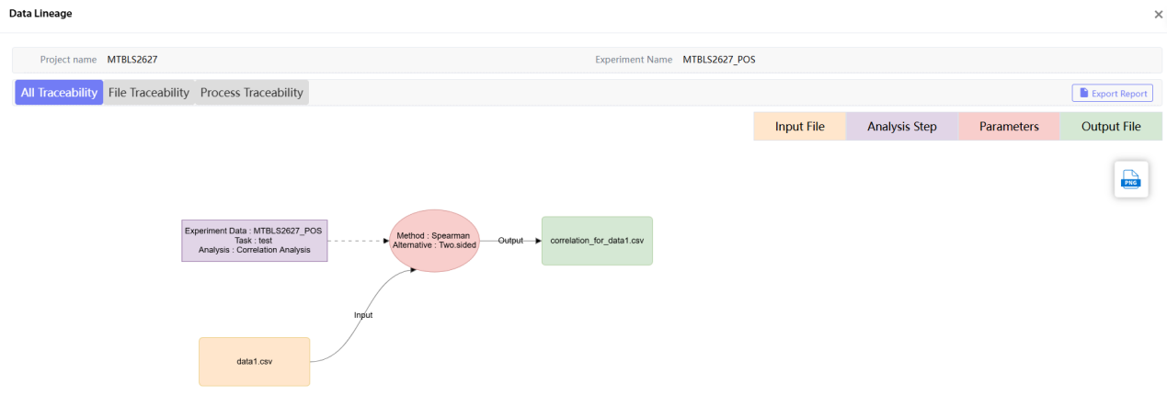
Figure 10.4 Correlation AnalysisTracing the source

10.2. Linear regression
Linear regression: Upload the data file, select the Dependent variable and Independent variable(s), and the relationship parameters between the dependent variable and the independent variable.
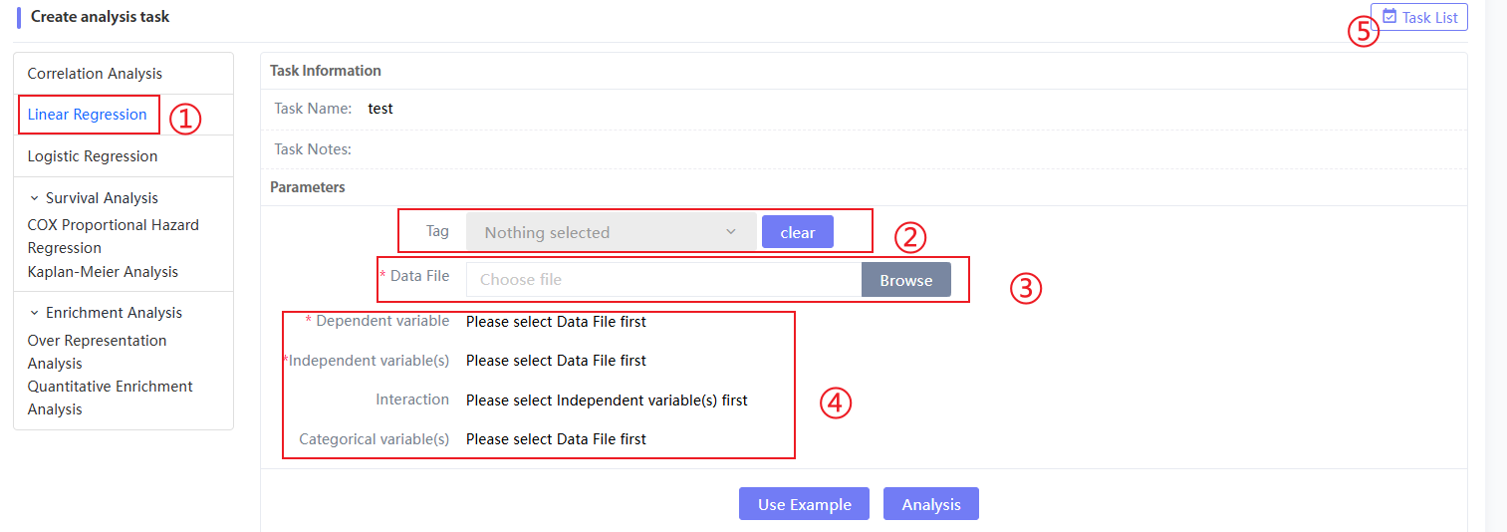
Figure 10.5 Linear regression parameter selection
When the Linear regression analysis is successful, enter the result page and you will get the specific Linear regression results. The result part consists of two parts. The correlation between the independent variable and the dependent variable is shown in the following figure.④, including various confidence levels; another part is the linear relationship diagram between the dependent variable and the independent variable.

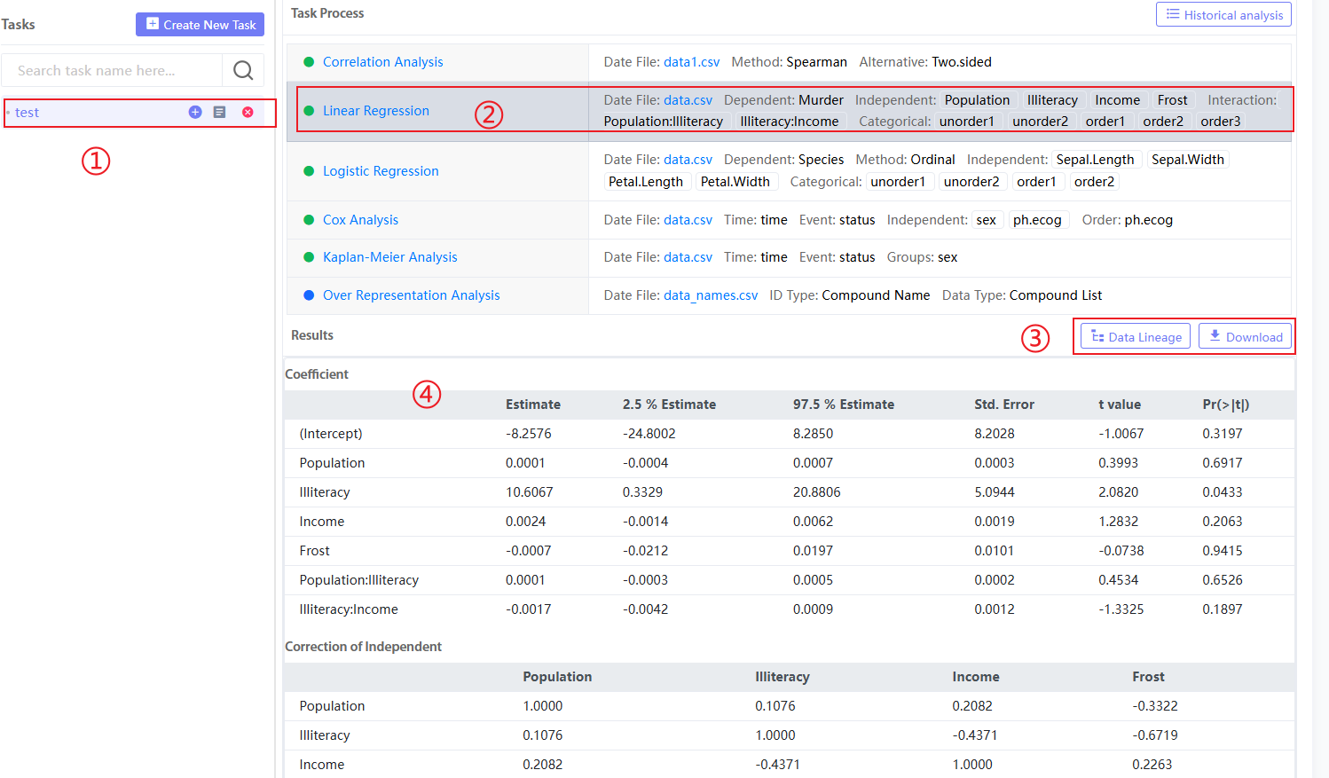
Figure 10.6 Linear regression results page
Figure 10.7③Both'Data lineage' and 'Download' can generate data traceability for this analysis step and download the result file to the local computer respectively. If you select the tag generated in the statistical analysis before, it will be convenient to connect the statistical analysis modules in series. The following figure shows a separate analysis without using tags, so the traceability content generated is less:
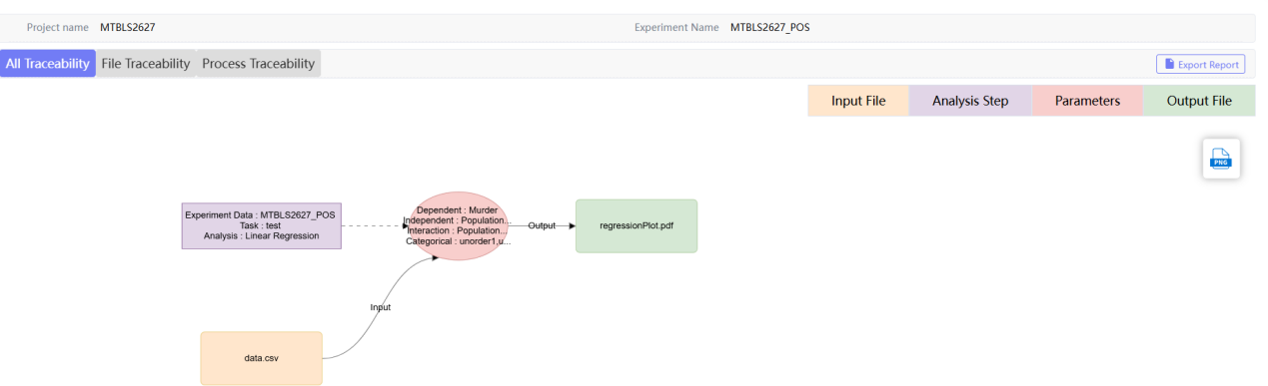
Figure 10.7 Linear regression result tracing

10.3. Logistic regression
Logistic regression: Upload the data file, select Dependent variable, Method, Independent variable(s), etc. for analysis
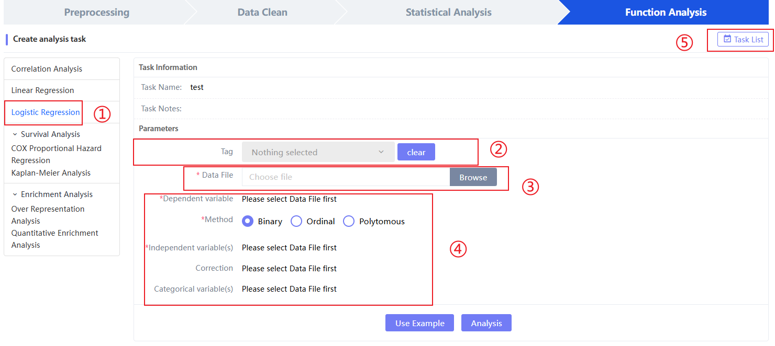
Figure 10.8 Logistic regression
When the Logistic regression analysis is successful, you will enter the result page to get the specific Logistic regression results. Currently, there is no online visualization result, only a download interface is provided.
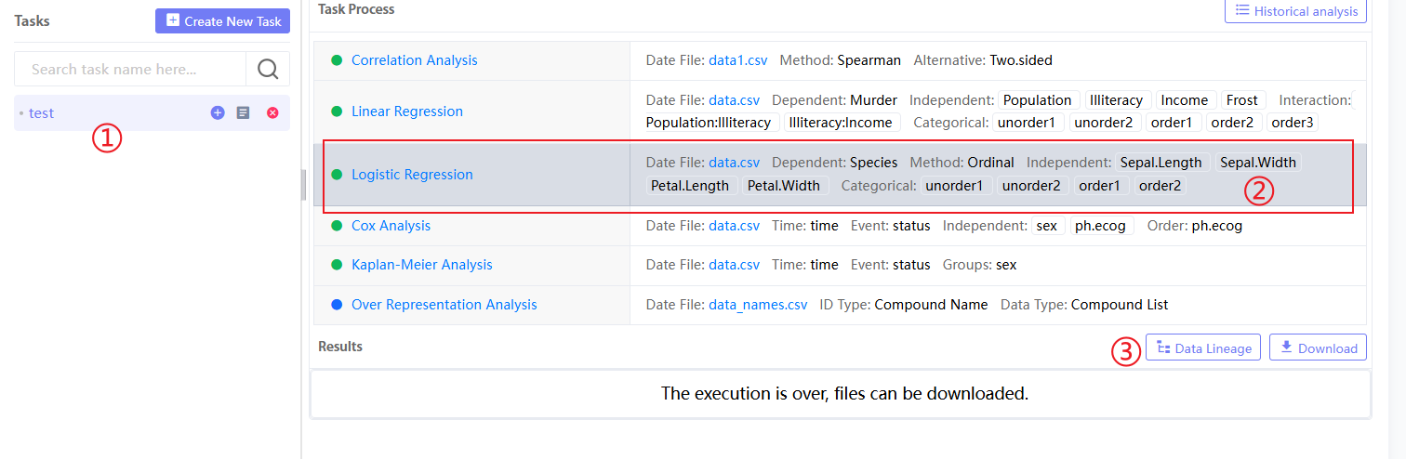
Figure 10.9 Logistic regression result page
Figure 10.9③Both'Data lineage' and 'Download' can generate data traceability for this analysis step and download the result file to the local computer respectively. If you select the tag generated in the statistical analysis before, it will be convenient to connect the statistical analysis modules in series. The following figure shows a separate analysis without using tags, so the traceability content generated is less:
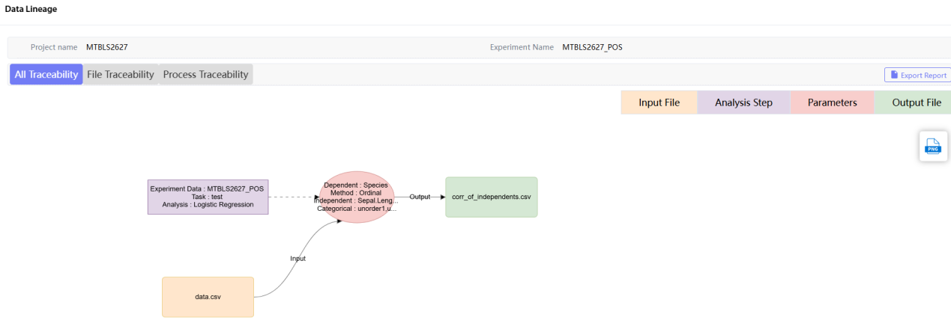
Figure 10.10 Logistic regression result tracing

Survival Analysis
Survival Analysis: includes COX Proportional Hazard Regression analysis and Kaplan-Meier Analysis.
In metabolic data analysis, COX regression analysis is often used to explore the association between metabolites and survival time. Through COX regression analysis, it is possible to determine which metabolites are associated with survival time and estimate the intensity of their impact on survival time. This helps to discover whether metabolites can be used as potential biomarkers for survival prediction or survival risk assessment. "Data File": a data file containing time series and metabolites. The first column is the sample name column. The system will parse the file after uploading; "Time": time series column name, selected by the user; "Event": event column name, generally a metabolite column, selected by the user.
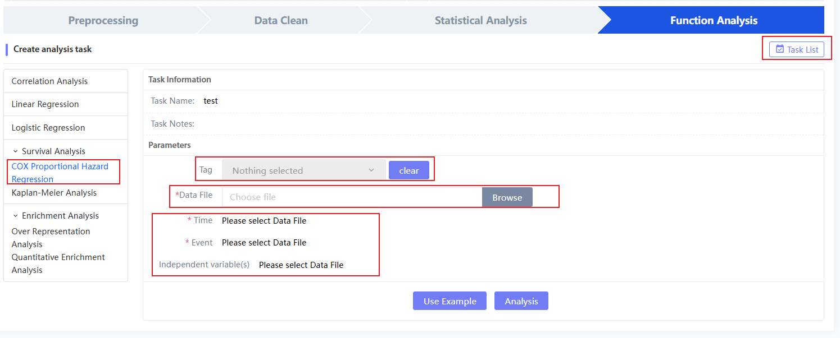
Figure 10.11 COX Proportional Hazard Regression Parameter Selection
When the Linear regression analysis is successful, you will enter the result page and get the specific Linear regression results. The result part is the survival indicator of the COX regression model.
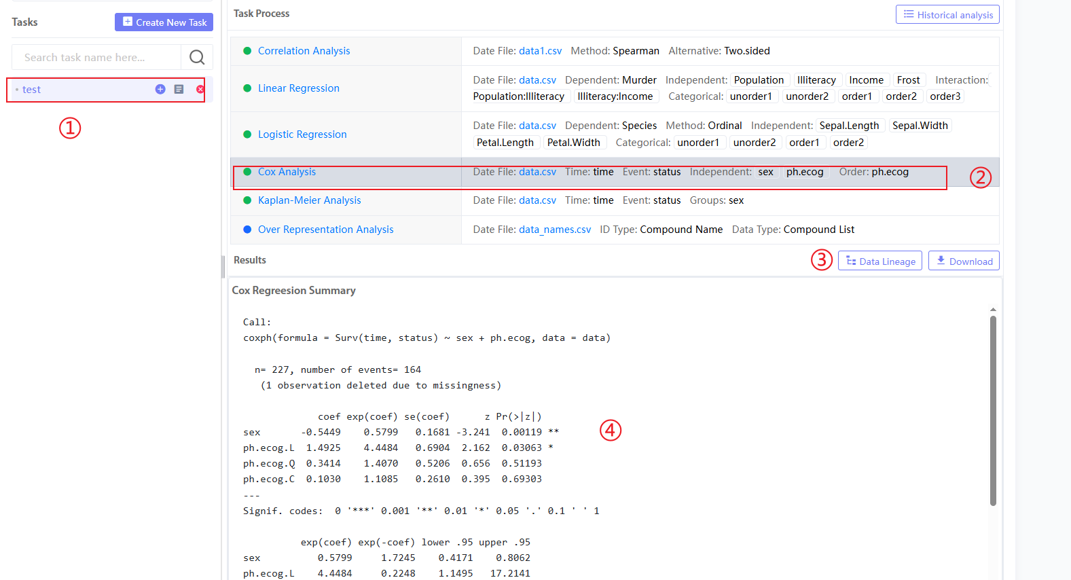
Figure 10.12 COX Proportional Hazard Regression results page
Figure 10.12③Both'Data lineage' and 'Download' can generate data traceability for this analysis step and download the result file to the local computer respectively. If you select the tag generated in the statistical analysis before, it will be convenient to connect the statistical analysis modules in series. The following figure shows a separate analysis without using tags, so the traceability content generated is less:
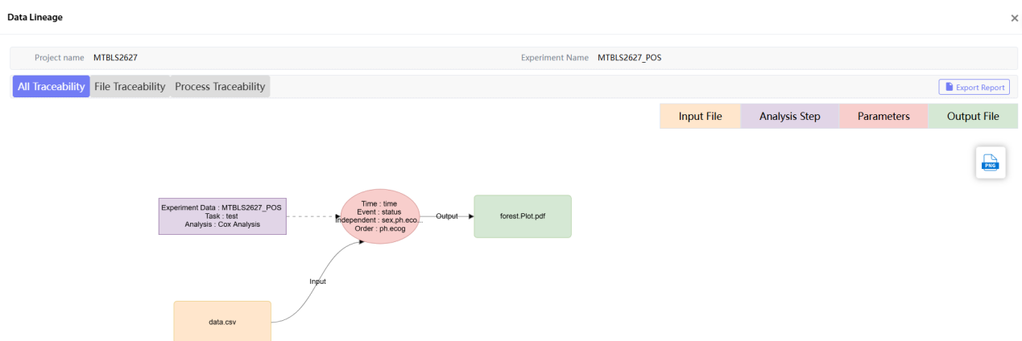
Figure 10.13 COX Proportional Hazard Regression Data Source

In metabolic data analysis, Kaplan-Meier Analysis is often used to study the relationship between metabolites and survival time. By drawing survival curves and estimating survival rates, we can understand the effects of different metabolites on survival and the differences therein. In addition, Kaplan-Meier Analysis can also compare survival curves between groups to help determine whether metabolites are related to survival time and whether there are differences between different groups. "Data File": a data file containing time series and metabolites. The first column is the sample name column. The system will parse the file after uploading; "Time": time series column name, selected by the user; "Event": event column name, generally a metabolite column, selected by the user; "Groups": group information column, generally one or two groups of information.
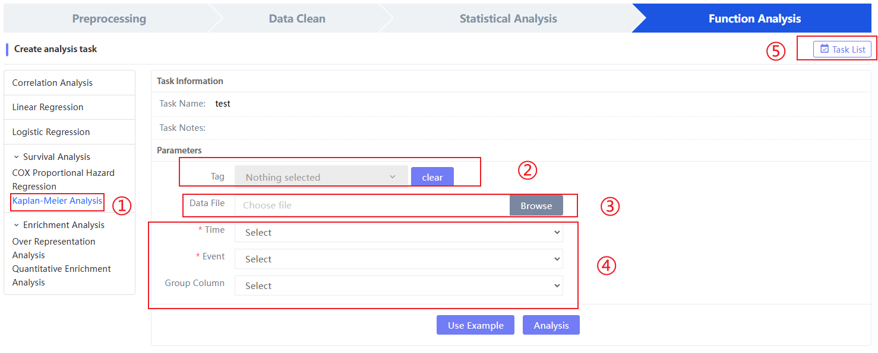
Figure 10.14 Kaplan-Meier Analysis Parameter Selection
When the Linear regression analysis is successful, enter the result page and you will get the specific Linear regression results. The result part consists of two parts: one is the curve of the survival curve over time.④; Another part of survival indicators.
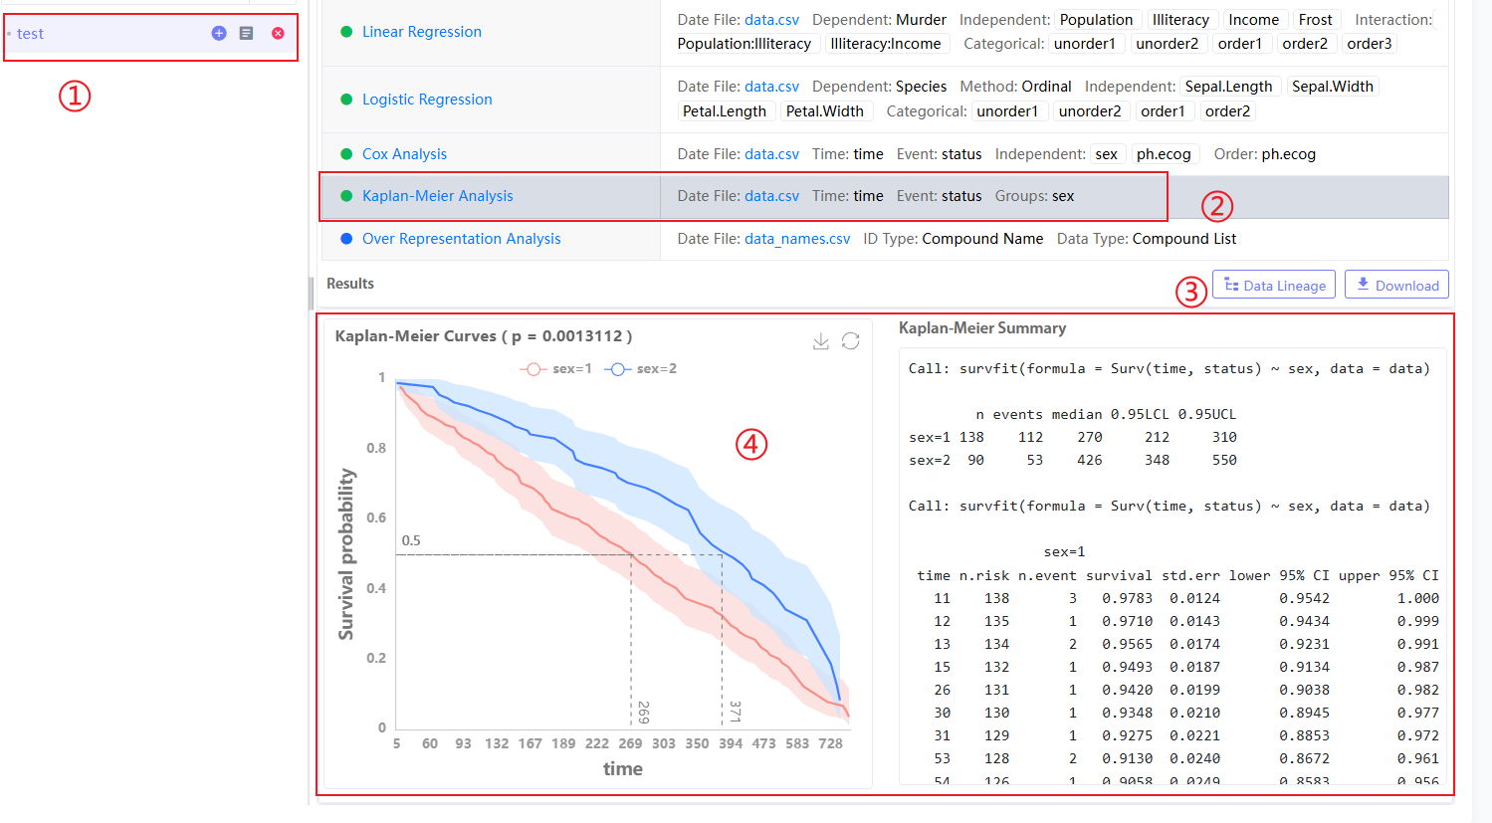
Figure 10.15 Kaplan-Meier Analysis Results Page
Figure 10.15③Both'Data lineage' and 'Download' can generate data traceability for this analysis step and download the result file to the local computer respectively. If you select the tag generated in the statistical analysis before, it will be convenient to connect the statistical analysis modules in series. The following figure shows a separate analysis without using tags, so the traceability content generated is less:
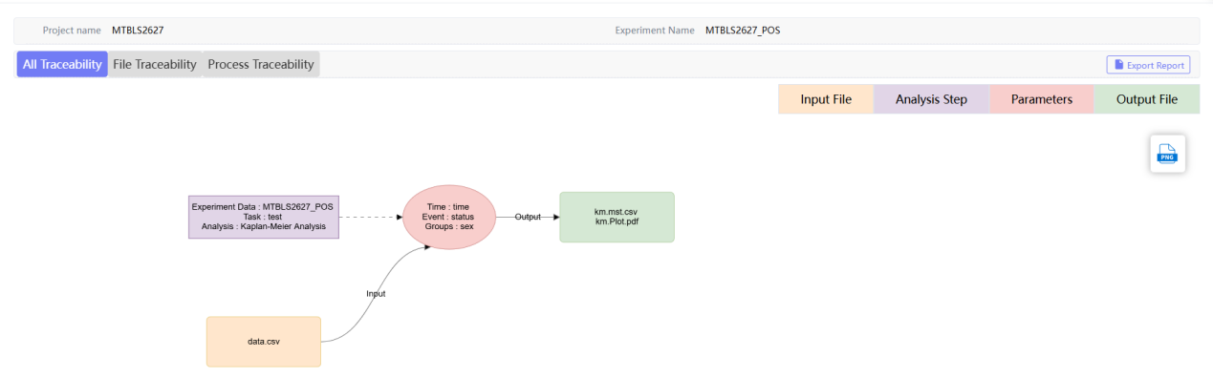
Figure 10.16 Kaplan-Meier Analysis Result Tracing

Enrichment Analysis
Enrichment Analysis: In metabolic data analysis, the purpose of enrichment analysis is to discover and understand the association between metabolite sets and specific metabolic pathways, biological functions or diseases. Through enrichment analysis, metabolic pathways or functions that are over- or significantly enriched in metabolite sets can be identified, and their importance in biological systems can be further inferred. In this platform, there are two processes: Over-Representation Analysis and Quantitative Enrichment Analysis.
Over-Representation Analysis (ORA) process: Over-Representation Analysis (QEA) analysis, by directly uploading the metabolite name or source library ID and then performing metabolite enrichment analysis. After entering the page, first select "Data Type" and "ID Type" for ID match (converted to KEGG database ID), then jump to enrichment analysis and select "Species" and "Database" parameters, "submit" jump to "Task List" generationORA Result Datadata.
Select "Data Type" and "ID Type": "Data Type" is the form of inputting metabolites, which can be directly copied and pasted into the white box, or uploaded as a csv file; "ID Type" is the metabolite form, which is divided into metabolite name (Compound Name) and other library IDs (KEGG, HMDB, etc.).
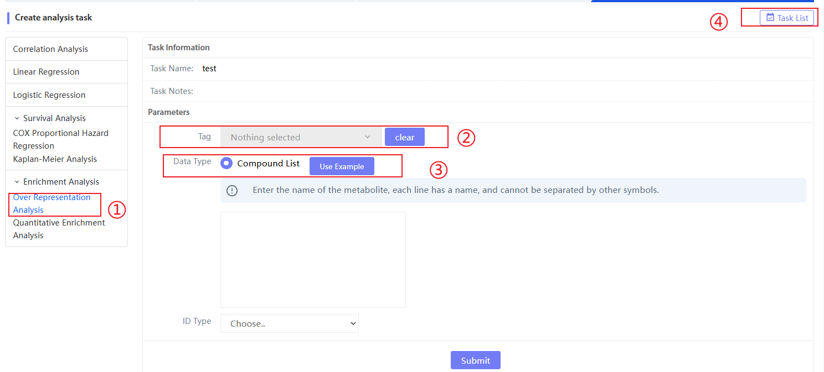
Figure 10.17 Over-Representation Analysis Process - ID Match
Select the "Species" and "Database" parameters: "Species" is the sample source type, currently only supports "has (Homo sapiens)"; "Database" includes two metabolic pathways, KEGG and SMPDB.
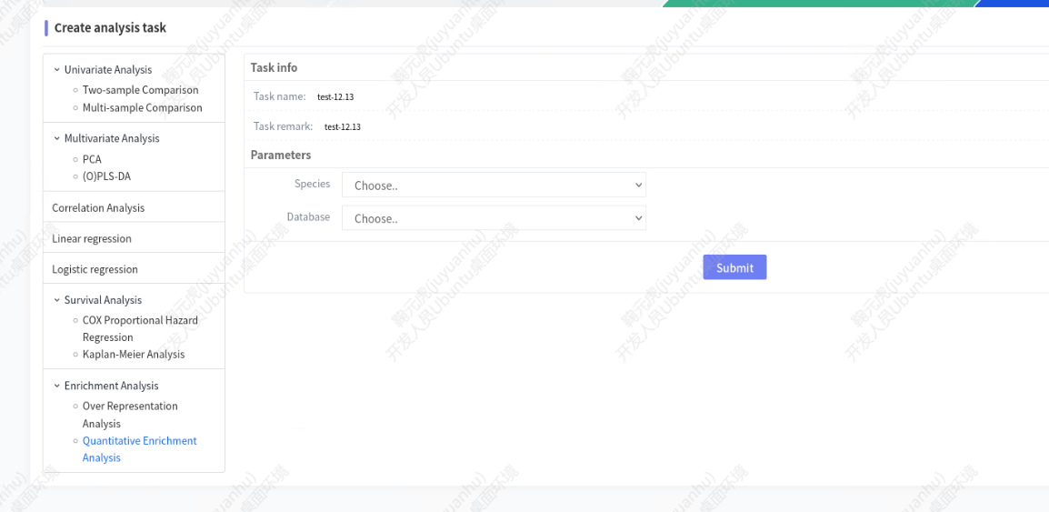
Figure 10.18 Over-Representation Analysis Process - Enrichment Analysis
Click "submit" to jump to the "Task List" generationOver-Representation Analysisresult data:
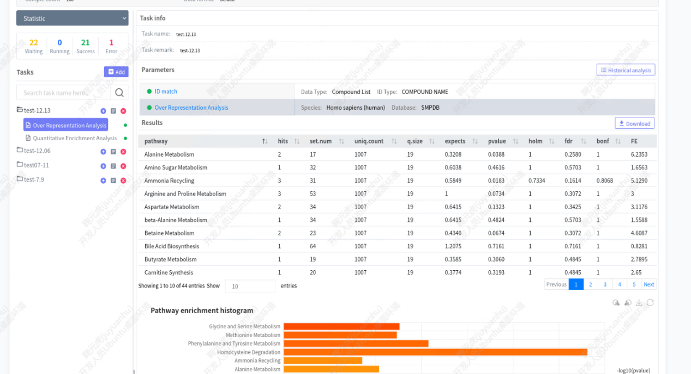
Figure 10.19 Over-Representation Analysis results
Result description:
- The online table shows the metabolite enrichment analysis results.
- Enrichment analysis graphics: bar chart and bubble chart, currently arranged from top to bottom according to enrichment.
Quantitative Enrichment Analysis: The analysis process of Quantitative Enrichment Analysis is basically the same as that of ORA: first perform metabolite "ID match" and then perform enrichment analysis. The difference is that the input of QEA is metabolite quantitative data, which requires additional data cleaning. Enter the QEA page, click "Browse" to upload the "SampleFile" and "DataType" csv files (containing metabolite quantitative information), select "ID Type" and click "submit" to jump to the second step of the analysis - data cleaning: [MissingValueProcessing] removes NA values ​​in metabolites, [Normalization] normalizes the data (if missing values ​​are not required, you can skip it directly). Finally, perform enrichment analysis, select "Species" and "Database" parameters, and click "submit" to jump to "Task List" to generate results.
- In the first step of the analysis, click "Browse" on the Quantitative Enrichment Analysis page to upload the "SampleFile" (containing the sample name and group information) and "DataType" files, and select "ID Type" (consistent with ORA).
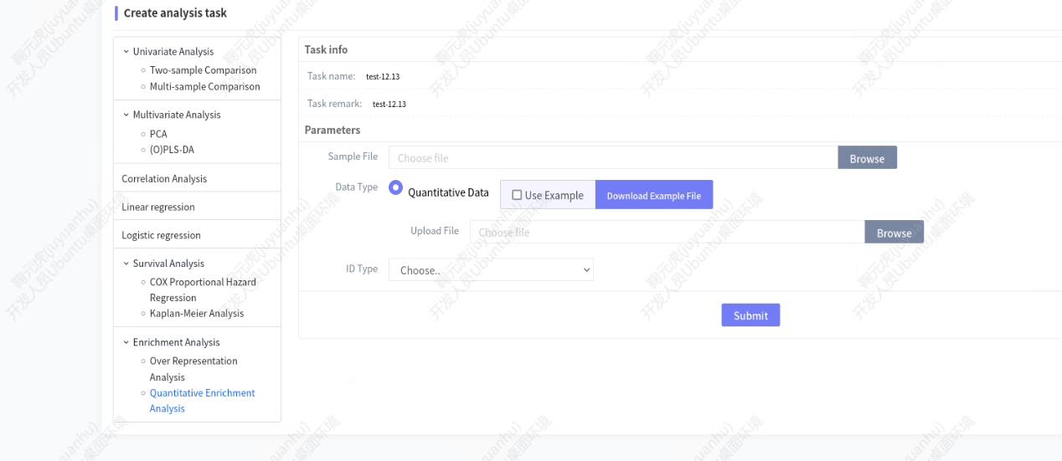
Figure 10.20 Quantitative Enrichment Analysis process - ID match
- In the second step of the analysis, select the Method parameter of MissingValueProcessing (can be skipped)
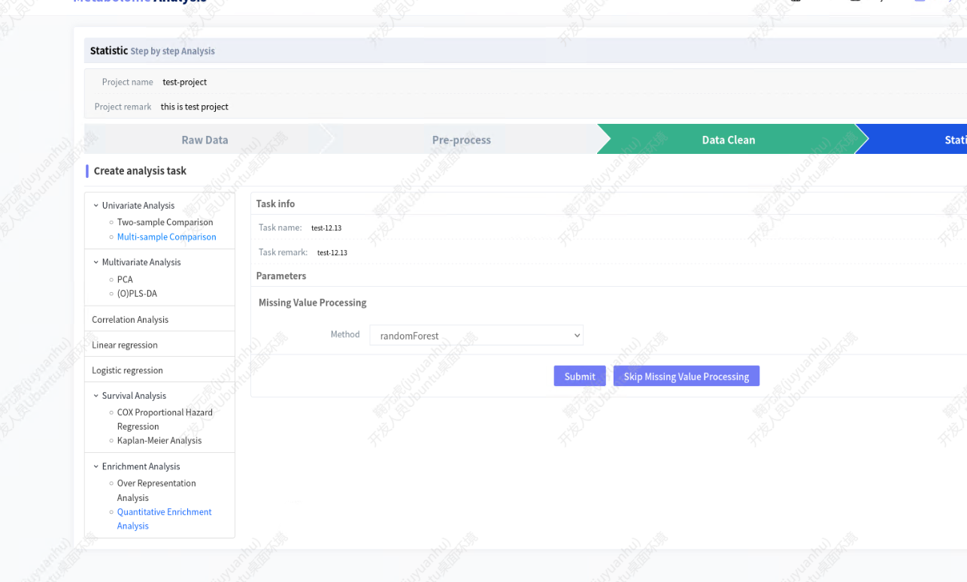
Figure 10.21 Quantitative Enrichment Analysis Process - Missing Value Processing
- The third step of the analysis is to select the Normalization Method parameter (optional)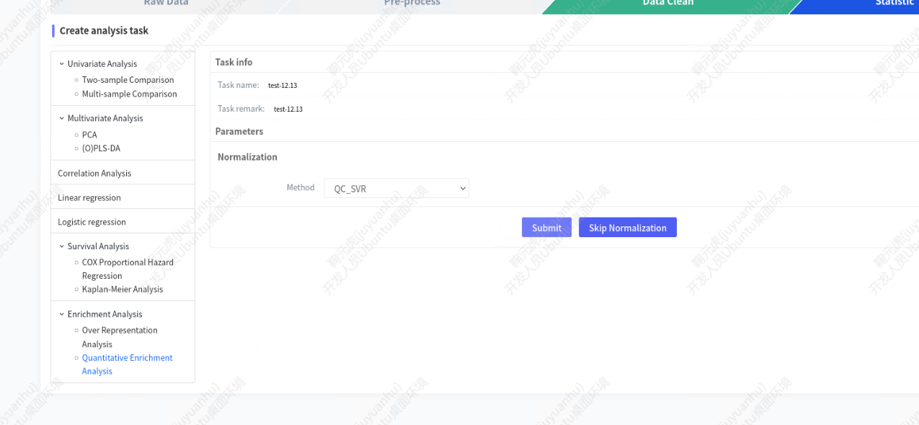
Figure 10.22 Quantitative Enrichment Analysis Process - Normalization
- Step 4: Select the "species" and "Database" parameters
Figure 10.23 Quantitative Enrichment Analysis Process - Enrichment Analysis

- Click "submit" to jump to "Task List" to generate QEA result data
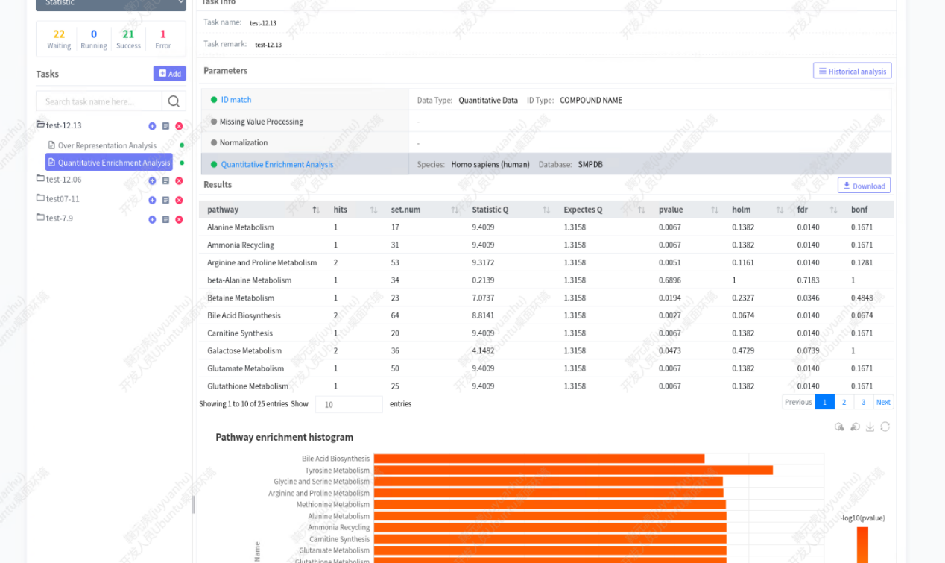
Figure 10.24 Quantitative Enrichment Analysis Process - Results
Result description:
- The online table shows the metabolite enrichment analysis results.
- Enrichment analysis graphics: bar chart and bubble chart, currently arranged from top to bottom according to enrichment.

One click analysis
In order to facilitate users to quickly clean data and perform statistical analysis to obtain differential characteristic peak results, we also provide a one-click analysis function. Users click "One click analysis" in the navigation bar "Analysis" to enter the one-click analysis interface. First, you need to select the corresponding project (see the figure below).①), then choose whether to upload data locally (②) or select the quantitative analysis data from the experimental data (⑤).
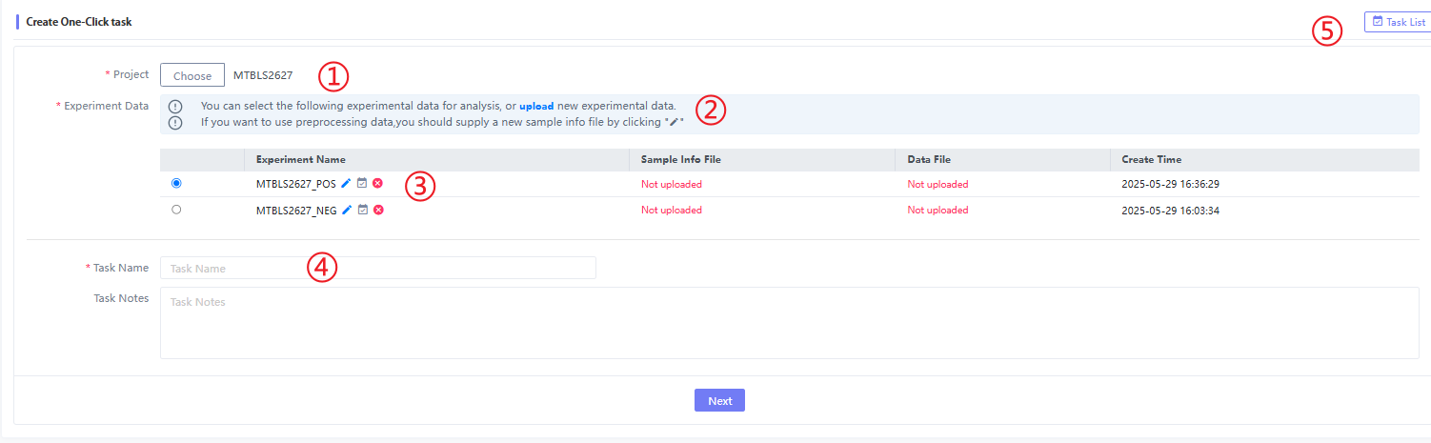
Figure 11.1 One click analysis'task
When entering the specific analysis page, there are currently all the analysis methods for data cleaning and two-sample comparison and multivariate analysis (PCA, PLS-DA, OPLS-DA) in statistical analysis. When entering this page for the first time, we default to "Missing value processing", "Normalization", "Fitered by RSD" and "PCA" for users. If users want to analyze other methods, they only need to select this analysis method. Just fill in the corresponding parameters as before, and submit with one click.
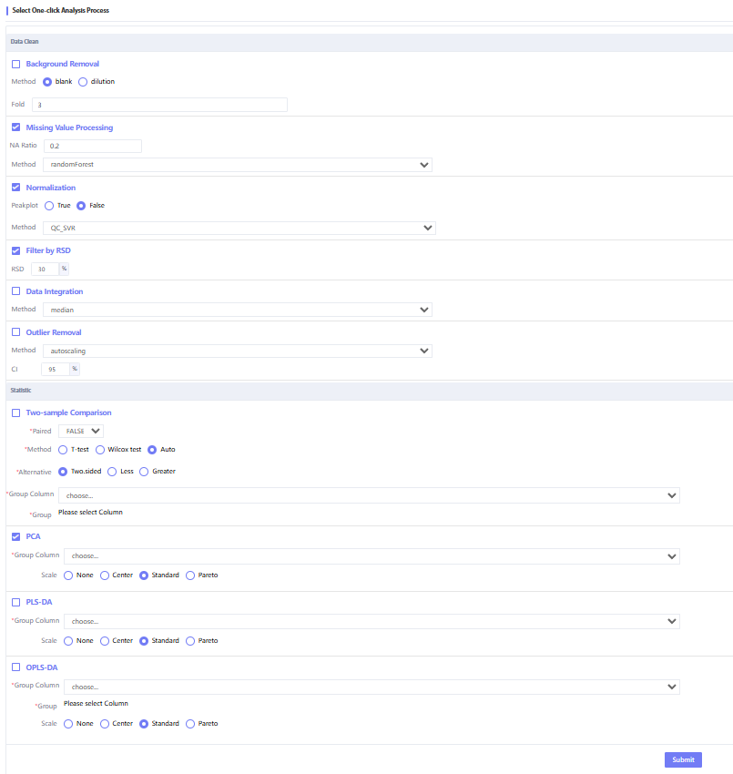
Figure 11.2 One click analysis parameter selection page

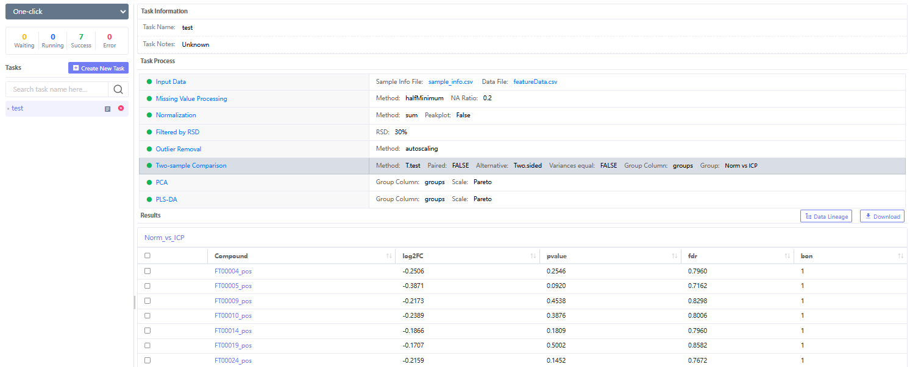
Figure 11.3 One click analysis results page
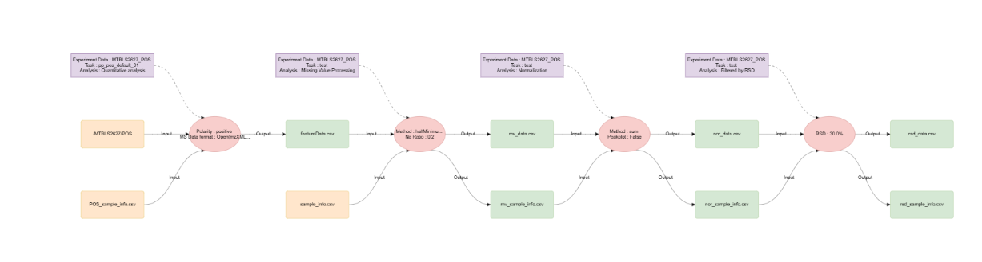
Figure 11.4 One click analysis traceability results

My Analysis
When there are too many analysis tasks and you don't know which project and task they are in, you can search them through "My Analysis" in the navigation bar. You can use fuzzy matching to search by "Task Name"; filter by module-specific analysis tasks by "Type"; filter by status classification by "Status" and filter by creation time.
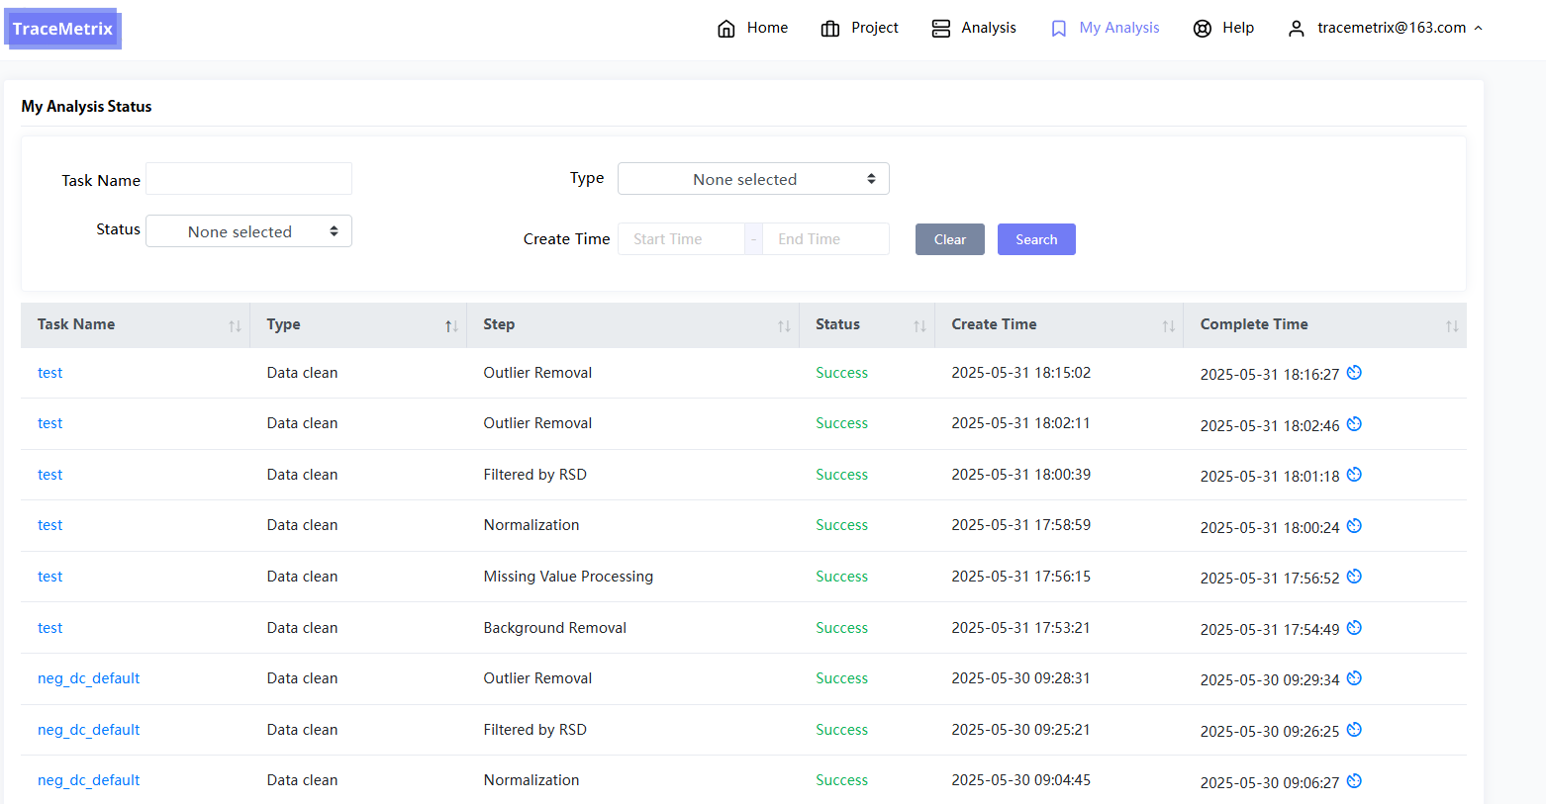
Figure 12.1: My Analysis page

Data lineage
In TraceMetrix, 'Data Lineage' is used to trace the "upstream" analysis path of all analysis results, forming a complete analysis path, which is convenient for users to better find and manage the analysis process. In all analysis result interfaces, the right side of the 'Results' section contains 'Data Lineage' for result tracing. Users only need to enter the result page to form the tracing results. In addition, we divide the tracing content into process tracing, software tracing and file tracing:

Process traceability
In this traceability, we only trace the process, so that users can clearly see which modules the input data passes through and what analysis methods ultimately lead to the final result. The following figure is an example of a process traceability:
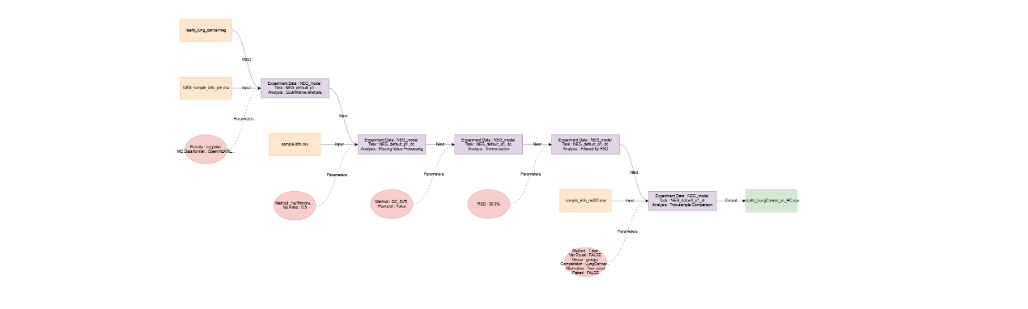
Figure 13.1: Process traceability

File traceability
In this traceability, we only trace the process files, so that users can clearly see which files the input data is transformed through to get the result file. The following figure is an example of a file traceability:
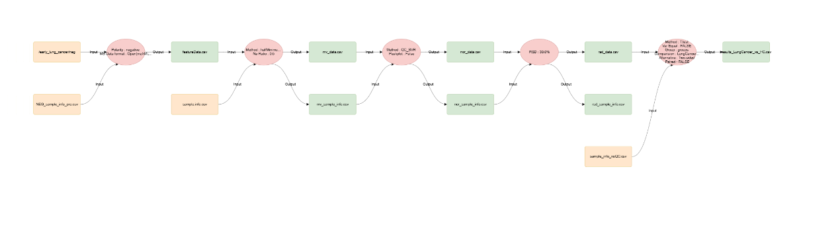Figure 13.2: File traceability

Software traceability
We document all the files, parameters, projects, experimental data, and task information involved in the traceability process, including specific parameters, R packages, and function information. Finally, we provide them for download in the form of documents, so that users can generate analysis methods with one click. The following figure is an example of software traceability:
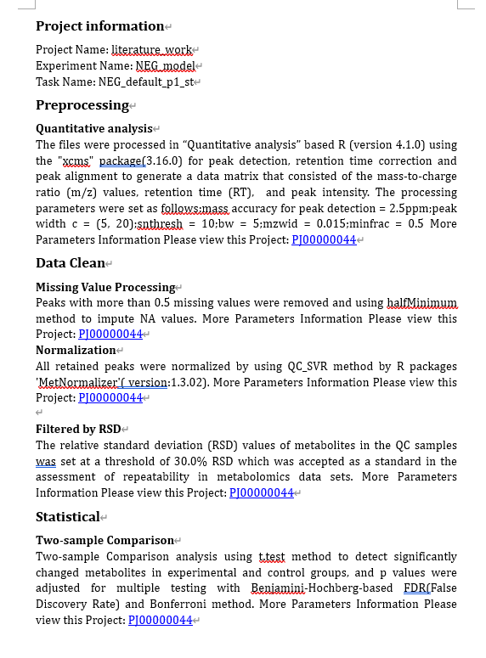
Figure 13.2: Software traceability

Help
The Help section describes the data requirements and data format requirements for each analysis step and provides demo data. Click Download to download the demo data for each step. If you have any questions about the analysis data format, please read and review this section.
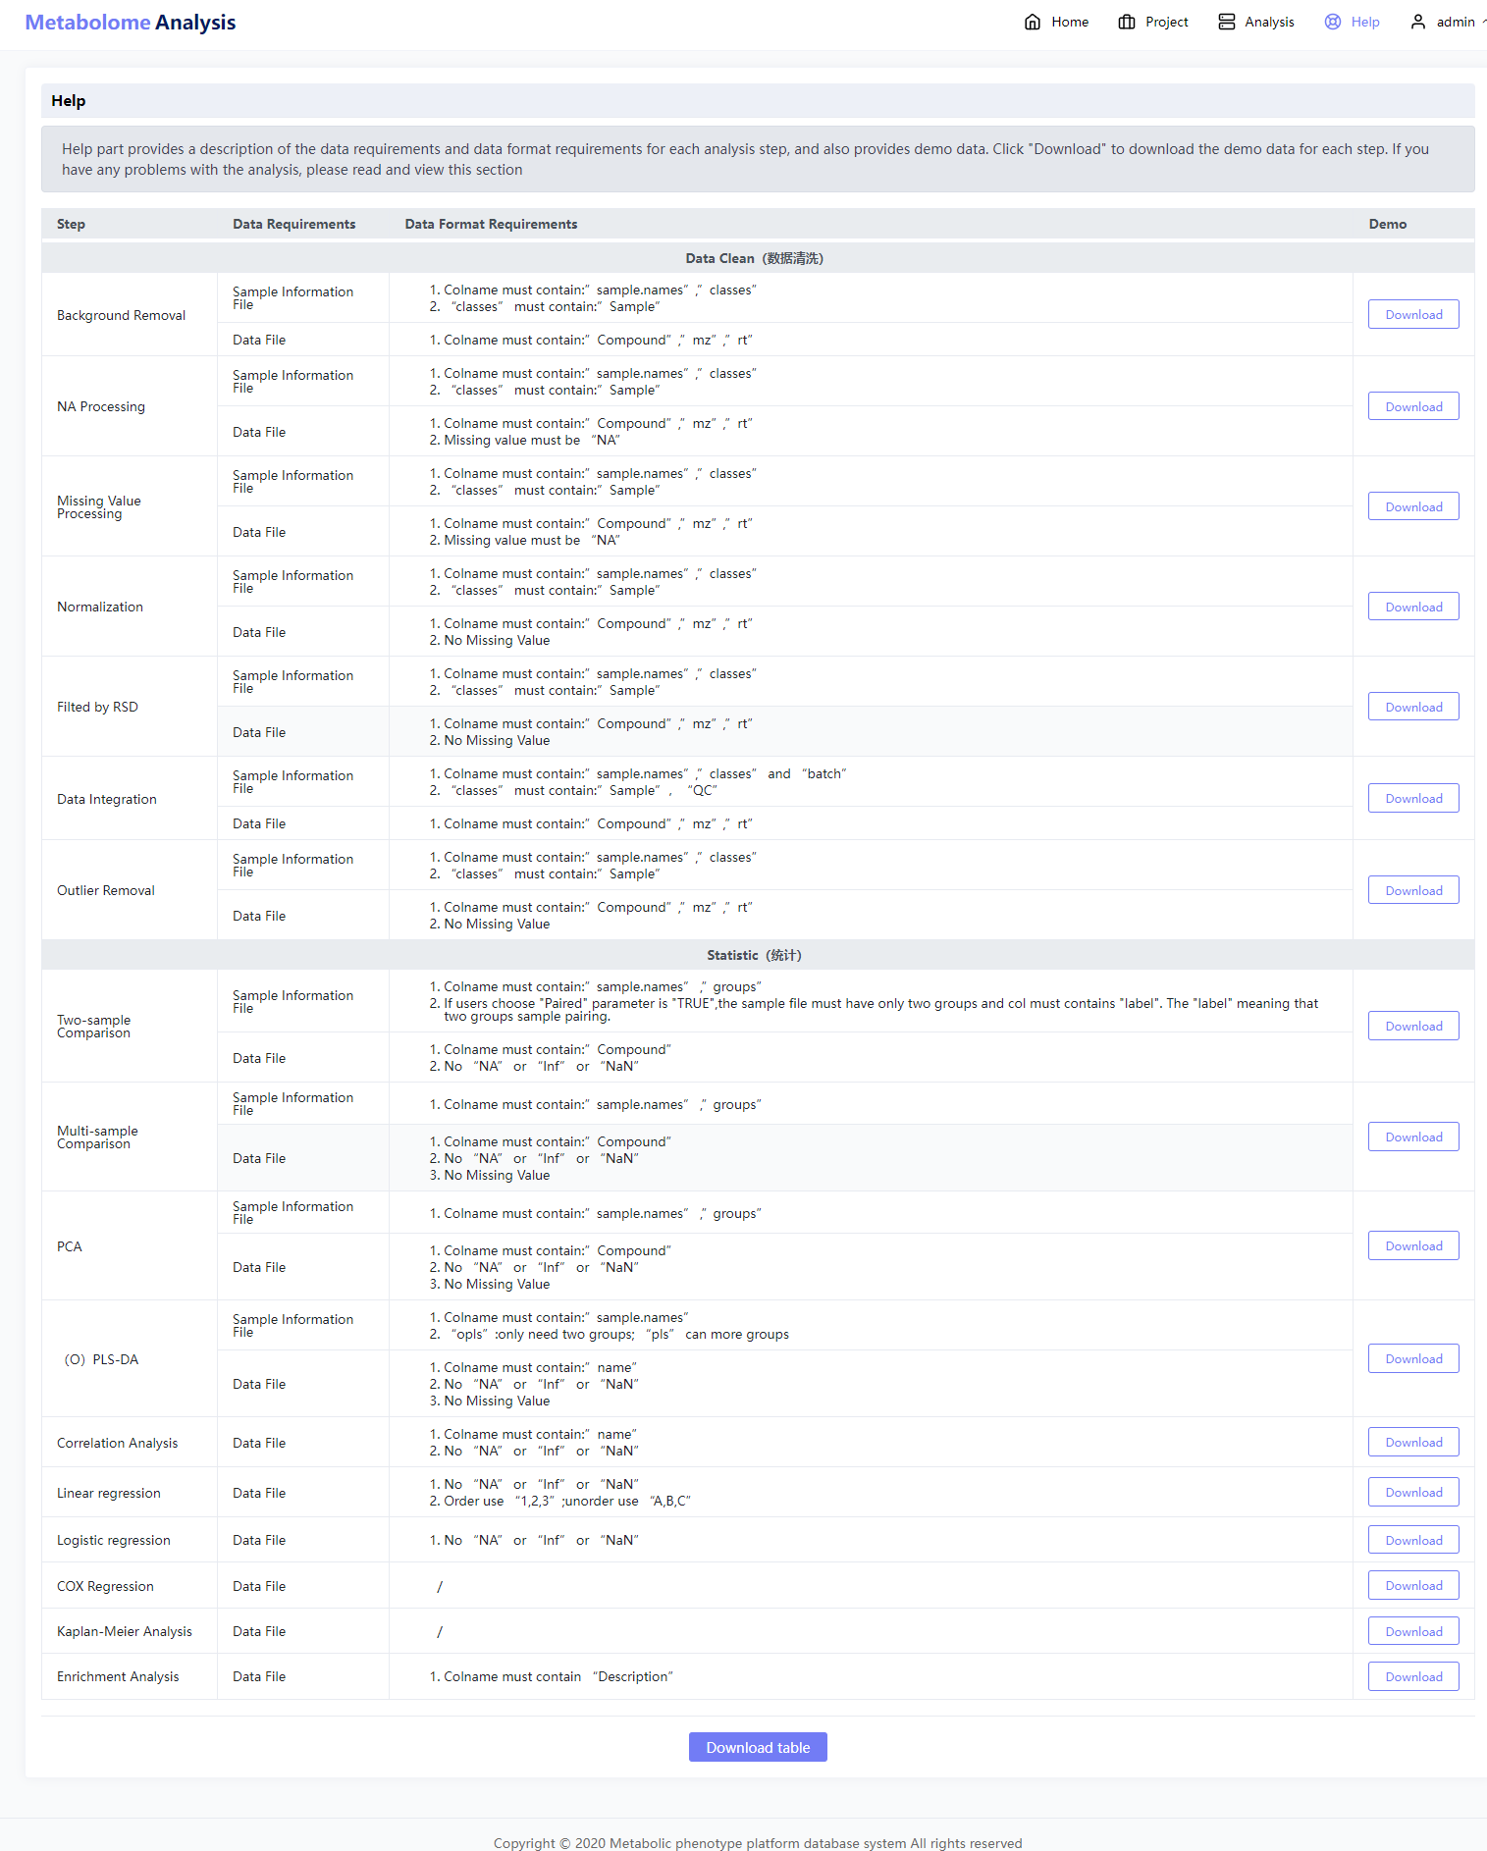
Figure 14.1 Help page

